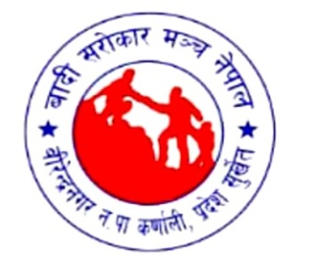
“afnaflnsfx?sf] ;'/Iff /fi6«sf] ;'/Iff xf]”
CHILD CARE IS CARE OF THE NATION
“hfu[t ;dfh dfkm{t pHjn elaZo agfpg ;lsG5”
AN ENLIGHTENED FUTURE IS OBTAINED THROUGH AWAKENED SOCIETY

rf}yf] aflif{s pT;j tyf klxnf] ;fwf/0f ;ef
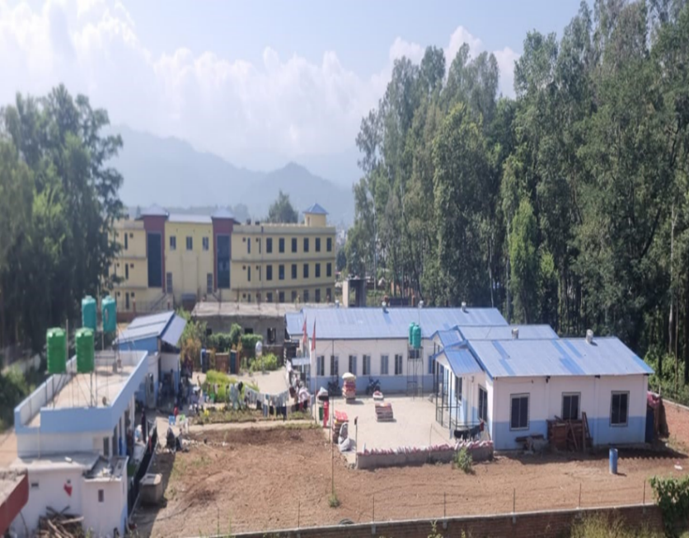
cf=a= @)*@/@)*#

afbL ;/f]sf/ d+r g]kfnsf] sfof{no kl/if/
k|ult k|lta]bg
afbL ;/f]sf/ d+r g]kfn
;+u7g lasf; laefu
aL/]Gb|gu/ gu/kflnsf *, Sofk; If]q s0ff{nL k|b]z
kmf]g g+=M )*# %()(%)
Website: bsmn.org
Email: nepalbcf@gmail.com
km];a'sM afbL ;/f]sf/ d+r g]kfn
Face Book: Badi Sarokar Manch Nepal
Twitter:
Instragram:
"gof+ kl/j]z, c6'6 kfO{nf
d]/f] egfO{
z}lIfs-cfly{s ;d[l4 tyf ;fdflhs Gofosf] lg/Gt/ ofqf"

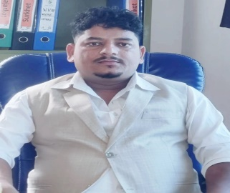
g]kfnL ;dfhsf] ;fdflhs ?kfGt/0fsf] sfo{df u}/;/sf/L ;+:yfx?n] dxTjk'0f{ e'ldsf v]Nb} cfO{/x]sf 5g\ . laz]if u/L @)$^ ;fnsf] /fhgLlts kl/jt{gkl5 ;fdflhs cleofgn] z;Qm e"ldsf v]n]sf]] kfO{G5 . u}/;/sf/L ;+:yfx?n] laZjAoj:yfsf] sdhf]/L, d"nwf/] lasf; cjwf/0ff / lasf; cEof;df /x]sf] cfwf/e"tvf]6x? cf}Nofpb} k|s[ltd}qL Pjd ;fdflhs GofonfO{ ;'lglZrtug]{ lbuf] lasf;sf] ckgfpg' kg]{ af/] ;hu u/fpb} cfPsf 5g\ . @)^@/)^# sf] /fhgLlts Aoj:yf kl/jt{g kZrft g]kfndf ;lbof}+ b]lv /fhgLlts, ;fdflhs tyf cfly{s / ;fdflhs Gofosf] d'nwf/af6 alx:s[t ?kdf /x]sf cNk;+Vos, l;dfGts[t tyf ;fdflhs, cfly{s tyf ;+f:s[lts ?kdf k5L kfl/Psf au{, hflt tyf ;d'bfon] cfkm\gf] klxrfg, xslxt, clwsf/ ;lxtsf] pTyfg tyf lasf;sf nflu laleGg sf]0fx?af6 ;+3if{ ub}{ cfPsf 5g\ . laut nfdf] ;do b]lv laz]if u/L klZrd g]kfn, s0ff{nL k|b]z, ;'b'/klZrd k|b]z tyf nl'DagL k|b]zsf cNk;+Vos, l;dfGts[t tyf ;fdflhs, cfly{s tyf ;+f:s[lts ?kdf k5L kfl/Psf au{, hflt tyf ;d'bfox?sf] ck]Iffs[t ?kdf ;sf/fTds kl/jt{g x'g g;ls/x]sf] kl/a]zdf laleGg cf/f]x ca/f]x kf/ ub}{ afbL ;/f]sf/ d+r g]kfnn] laut & aif{ b]lv ;'lawf lalxg afnaflnsfx?sf] ;+/If0f, lzIff / pgLx?sf] zf/Ll/s tyf dfgl;s lasf;sf] nflu sfd ub}{ cfPsf] 5 . ;g @)@% b]lv o; ;+:yfn] afn;+/If0fsf ;fy;fy} Gofok'0f{ Pjd lbuf] z}lIfs-cfly{s cj:yf ;lxtsf] ;Dd'gt, nf]stflGqs / ;dtfd'ns ;dfhsf] lgdf{0fsf nflu Plss[t ?kdf ;d'bfo txd flasf; tyf k}/aLsf sfo{qmdx? ;+rfng ug]{ of]hgf ;lxt cuf8L al9 /x]sf] 5 .
lxSdtaxfb'/ afbL
cWoIf-afbL ;/f]sf/ d+r g]kfn

laleGg cefjsf lar la=;+= @)&# df cleefjs lalxg, laleGg sf];Ldsf hf]lvddf /x]sf tyf ;fdflhs cfly{s cefjsf sf/0f lzIff k|fKt ug{ gkfPsf afbL ;d'bfosf !^ hgf caf]w afnaflnsfx?af6 lxSdt xf]:6]naf6 z'? ePsf] afn ;+/If0fsf] cleofg afbL ;/f]sf/ d+r g]kfn gfds ;+:yfsf] cu'jfO{df cfkm\g} cfjf; ejgdf Aojl:yt ?kdf afn ;+/If0f s]Gb| -5fqaf;_ df kl/0ft eO{ cuf8L al9 /x]sf] 5 . xfn o; 5fqaf;df laleGg k|b]zsf afbL ;d'bfosf !!) hgf afnaflnsfx? a:b} cfPsf 5g\ . pgLx?n] ;'/lIft af;:yfgsf ;fy} u'0f:t/Lo lzIff nuft :jf:Yo tyf lhag pkfof]uL ;Lkx? Klg k|fKt u/L/x]sf 5g\ . afn ;+/If0fsf cltl/Qm afbL ;/f]sf/ d+r g]kfnn] afbL ;d'bfodf cfocfh{g, ;Lkd'ns tflnd, clwsf/df cfwfl/t sfo{qmdx? ;+rfng ub}{ cfO{/x]sf] 5 . afbL ;/f]sf] d+r g]kfnsf] rf}yf] aflif{s pT;j tyf klxnf] ;fwf/0f ;efsf] nflu k|ult k|lta]bg tof/ ug'{x'g] ;+u7g lasf; laefu nufot ;+:yfsf ;Dk'0f{ sd{rf/L, :jod;]asx?nfO{ xflb{s cfef/ k|s6 ub}{ wGoafb lbg rfxG5' .

afbL ;/f]sf/ d+r g]kfn ;d'bfosf ;a} AolQmx?sf] z;lQms/0f, l;+uf] ;d'bfosf] d'nk|aflxs/0f, ;+:yfut txdf lg/Gt/ l;sfO{, 1fg lgdf{0fdf ;+nUgtf ;lxtsf] ?kfGtsf/L sfo{, :yfgLob]lv laZjtxsf] ;xsfo{df laZjf; ub{5 . ;bfem} kl5 kfl/Psf ;d'bfosf dlxnf, afnaflnsf tyf o'jfx?sf] pTyfgsf nflu cfufdL lbgdf ;fdflhs Gofo tyf lasf;sf] If]qdf sfo{/t ;+:yf, af}l4s ;d'bfo, ;/sf/L lgsfo / cGt//fli6«o ;fem]bf/ ;+:yfx?sf] cy{k'0f{ ;/;xof]u / /rgfTds ;xsfo{sf] ck]Iff ub{5' . ;dtfd'ns lbuf] lasf;sf] cleofgdf afbL ;/f]sf/ d+r g]kfn of]ubfg ug{ ;b}j sl6a4 / k|lta4 5 . afbL ;/f]sf/ d+r g]kfnsf ;b:ox?, ;+rfns ;ldtL, ;+:yfsf sd{rf/Lx? / k/fdz{bftfx? k|ult k|lta]bg tof/Lsf] z'? b]lv cGTo;Dd g} laleGg ls;Ldaf6 lg/Gt/ ;+nUg eO{ cfkm\gf] larf/, laZn]if0fsf] ;fy} laleGg nfeflGjt ;d'x, ;/f]sf/jfnfx?sf /fo / larf/x? ;+sng u/]/ dxTjk'0f{ of]ubfg lbg'eof] . afbL ;/f]sf/ d+r g]kfn kl/jf/ / d]/f] AolQmut tkm{af6 ;a}nfO{ wGoafb / s[t1tf 1fkg ub{5' .

z'esfdgf ;Gb]z

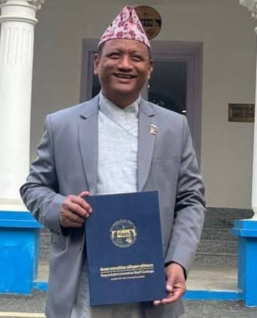
afbL ;/f]sf/ d+r g]kfnn] cfkm\gf] rf}yf] aflif{s pT;j tyf klxnf] ;fwf/0f ;ef cfof]hgf ug]{ sfo{qmddf ;+:yfsf] :yfkgf sfn b]lv xfn;Ddsf] ultlalwnfO{ ;dfa]z u/L ;+:yfsf] klxnf] k|ult k|lta]bg k|sfzg ug{ nfu]sf] z'e cj;/df d+raf6 ePsf pNn]vgLo sfo{ tyf of]ubfgnfO{ :d/0f ug{ rfxG5' . ;fdflhs, cfly{s tyf /fhgLlts ?kdf k5f8L k/]sf] afbL ;d'bfo laz]iftx afnaflnsfx?sf] lzIff k|fKtL / ;d'bfosf] clwsf/ :yfkgfsf] nflu pbfx/0fLo kl/0ffd k|fKt x'g] u/L sfd ug{ ;s]sf]df d+r k|lt uf}/jfGjLt 5' . laz]iftx s0ff{nL k|b]z ;/sf/af6 k|fKt sfo{ lhDd]jf/L lgaf{x ug]{ qmddf d]/f] ;+of]hsTjdf ul7t ;ldtLsf] tkm{af6 afbL ;d'bfosf] pTyfg tyf lasf;sf] nflu cWwog k|lta]bg / s0ff{nL k|b]zsf afbL ;d'bfosf] k|f]kmfO{n tof/L ug{ afbL ;/f]sf/ d+r g]kfnaf6 ePsf] ;xof]u, ;xsfo{, ;dGjo / of]ubfgsf] nflu laz]if wGoafb lbg rfxG5' . ;+:yfsf] k|ult k|lta]bgsf] k|sfzgaf6 cfd ?kdf afbL ;/f]sf/ d+r g]kfnsf] laZjf;nfO{ yk alnof] agfpg tyf ;+:yfsf] sfo{If]qdf kf/blz{tf, hjfkmb]lxtf k|aw{g ug{ laz]if an k'Ug] laZjf; lnb} afbL ;/f]sf/ d+r g]kfnsf] ultlalwaf6 l;dfGts[t tyf kl5 kfl/Psf ;d'bfox? laz]if u/L afbL ;d'bfon] ;fdflhs, ;f+:s[lts, cfly{s tyf /fhgLlts nufotsf] ;a} If]qdf ;kmntf k|fKt ug{ ;sf]; egL z'esfdgf k|bfg ub{5' .
cfgGb ;f?
k|b]z ;lrj
d"VodGqL tyf dGqLkl/ifbsf] sfof{no
s0ff{nL k|b]z, ;'v]{t

wGoafb @)*!/!!/@@

z'esfdgf ;Gb]z

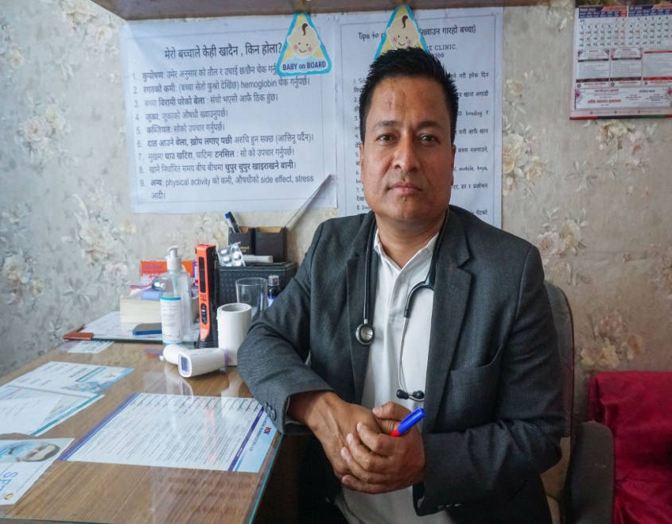
clt g} klaq pb]Zosf cfkmgf ;dflhs ultalwx? ;+rfng u/L /x]sf] afbL ;/f]sf/ d+r g]kfnn] cfkm\gf] rf}yf] aflif{s pT;j tyf klxnf] ;fwf/0f ;ef cfof]hgf ug{ nfu]sf]df ;a{k|yd sfo{qmd ;kmntfsf] z'esfdgf lbg rfxG5' .

;fdflhs tyf cfly{s ?kdf clt g} lakGg cj:yfdf /x]sf] afbL ;d'bfo laz]iftx afnaflnsfx?sf] lzIff, :jf:Yo k|fKtL / ;d'bfosf] clwsf/ k|flKtsf nflu ;+3if{/t ;+:yf afbL ;/f]sf/ d+r g]kfn / o;sf] g]t[Tjstf{ cleoGtf pxfsf] sfo{;ldtLnfO{ pQ/f]Q/ k|ultsf] sfdgf ;d]t ub{5' .
8f= gj/fh s]=;L=
afn /f]u laz]if1
sfo{/t, g]kfn afn kf]lnlSgs, Wings Foundation and Karnali Care Hospital

d"VodGqL tyf dGqLkl/ifbsf] sfof{no
s0ff{nL k|b]z, ;'v]{t

laz]iftx :jf:YosdL{ tyf ;dfh;]aLsf] ?kdf lhDd]jf/L lgaf{x ug]{ qmddf To; ;+:yf4f/f ;+/lIft afnaflnsfx?sf] :jf:Yo pkrf/, zf/L/Ls lasf; tyf snf ;Lk l;sfpg] qmddf afbL ;/f]sf/ d+r g]kfnaf6 ePsf] ;xof]u, ;xsfo{, ;dGjo / of]ubfgsf] nflu laz]if wGoafb lbg rfxG5' . ;+:yfsf] k|ult k|lta]bgsf] k|sfzgaf6 cfd ?kdf afbL ;/f]sf/ d+r g]kfnsf] ;DaGwnfO{ yk alnof] agfpg tyf ;+:yfsf] sfo{If]qdf kf/blz{tf, hjfkmb]lxtf k|aw{g ug{ laz]if of]ubfg k'Ug] laZjf; lnb} afbL ;/f]sf/ d+r g]kfnsf] ultlalwaf6 l;dfGts[t tyf kl5 kfl/Psf ;d'bfox? laz]if u/L afbL ;d'bfon] ;kmntf k|fKt ug{ ;sf]; egL z'esfdgf k|bfg ub{5' .

wGoafb .

afbL ;/f]sf/ d+r g]kfnsf] rf}yf] aflif{s pT;j tyf klxnf] ;fwf/0f ;ef
cfly{s aif{ @)*@/@)*#

!= ;+:yf kl/ro M
!=! k[i7e"ld
afbL ;/f]sf/ d+r g]kfn afbL ;d'bfo nufot cNk;+Vos, l;dfGts[t, c;fxo tyf kl5 kfl/Psf ;d'bfosf] pTyfg ug]{ pb]Zo /flv @)&* c;f]]h * ut] sDklg /lhi6/sf] sfof{no sf7df08f}+df gfkmf gug]{ sDklgsf] ?kdf btf{ eO{ @)&( ;fndf ;dfh sNof0f kl/ifbdf klg cfa4 ePsf] 5 .

g]kfnL ;dfhdf cem}klg hflto tyf n}lËs lae]b, hflto 5'jf5't, dlxnf tyf afnaflnsfx? dfly of}g tyf 3/]n' lx+;f, of}g zf]if0f tyf b'Ao{axf/, dfgj a]rlavg, 5fpk8L, afnlaafx, ax'laafx, afn>d tyf zf]if0f h:tf ;d:ofx? /x]sf 5g\ . cem} klg o:tf ;d:ofx?nfO{ ;fdflhs dfg, k|lti7f, O{Hht, nfh, 8/ / ;fgf] 7'nf] ?kdf lnO{g] x'bf lkl8tn] emg} kL8f v]Kg'kg]{ / kL8sn] af/Daf/ To:tf 36gfx? bf]x/\ofpb} hfg] cj:yf /x]sf] 5 . s0ff{nL, n'DaLgL, ;'b'/klZrd nufotsf k|b]zx? Afnaflnsf tyf o'jfx? hf]lvdk'0f{ cj:yfdf /x]sf 5g\ . t;y{ afbL ;/f]sf/ d+r g]kfnn] o:tf blaPsf tyf hf]lvd cj:yfdf /x]sf dlxnf afnaflnsf tyf o'jfx?nfO{ ;+u7gfTds ?kdf z;Qm ub}{ pgLx?nfO{ cfly{s, ;fdflhs tyf /fhgLlts ?kdf d"nk|aflxs/0f ug]{ cleofgdf nfu]sf] 5 .

afbL ;/f]sf/ ;/f]sf/ d+r g]kfnn] @)^( ;fn b]lv clt g} lakGg cj:yfdf /x]sf afbL ;d'bfosf cgfy c;fxo afnaflnsfx?nfO{ ;+/If0fsf ;fy} pgLx?nfO{ u'0f:t/Lo lzIff k|bfg ub}{ cfO{ /x]sf] 5 . afbL ;/f]sf/ d+r g]kfnn] afnaflnsfx?sf] ;+/If0f / lzIffsf cltl/Qm l;+uf] afbL ;d'bfonfO{ z;Qm ub}{ ;dfh tyf /fHosf] d"nk|afx u/fpg] c7f]6 lnPsf] 5 . afbL ;/f]sf/ d+r g]kfnn] afbL ;d'bfo nufot cGo blnt, cNk;+Vos, ;'lawf lalxg tyf kl5 kfl/Psf ;d'bfodf afn ;+/If0f tyf k|a{wg, Plss[t ;fd'bflos lasf;, u'0f:t/Lo lzIff tyf /f]huf/, ;fdflhs ;dfa]zLs/0f tyf d"nk|aflxs/0f / ;+:yfut lasf; h:tf d'Vo laifox?df s]Gb|Lt /lx ;+:yfsf] klxnf] tLg alif{o /0fgLlt of]hgf @)@%-@)@&_ cGtu{t /lx cfkm\gf sfo{qmdx? ;+rfng ug{ nfu]sf] 5 .

!=@ kl/sNkgfM
lzIff, :jf:Yo, hLlasf]kfhg{g, k|ltgLlwTj ;lxt >f]t, ;]jf / lg0f{o k|s[ofdf kx'rsf] cj:yfsf cfwf/df ;d'bfosf] u'0f:t/Lo cj:yfnfO{ dfkg ug{ ;lsG5 . afbL ;/f]sf/ d+r g]kfn o:tf] ;dfhsf] sNkgf ub{5, hxf+ “l;dfGts[t, ;'lawflalxg tyf kl5 kfl/Psf ;d'bfosf dlxnf tyf k'?ifx?sf] z;lQms/0f tyf ;dfa]zLs/0f ;'lglZrt x'G5” To;}n] afbL ;/f]sf/ d+r g]kfn “;DDfflgt / ;d[4 ;dfh x]g{ rfxG5 “ .

!=# Wo]oM
afbL ;/f]sf/ d+r g]kfnsf] cleofg Dffgj lasf;sf] nflu z;lQms/0f / d'nk|aflxs/0fsf] :t/ agfpg afbL ;d'bfo nufotsf l;dfGts[t / alx:s[t ;d'bfo;+u ldn]/ sfd ug'{ xf] .

!=$ nIoM
;dfa]zL a[l4 lasf;sf] nflu afbL ;d'bfo nufot l;dfGts[t tyf hf]lvddf /x]sf ;d'bfox?nfO{ pgLx?sf] clwsf/ pkof]usf nflu z;Qm / d'nk|aflxs/0f ug]{ afbL ;/f]sf/ d+r g]kfnsf] nIo /x]sf] 5 .

!=$ pb]Zo
- lasf;lzn pb]Zo M
;fdflhs, cfly{s / /fhgLlts cj;/x? ;'/lIft ug{ dlxnf, afnaflnsf / o'jfx?sf] ;+:yfut tyf AolQmut IfdtfnfO{ ;'b[9 ub}{ g]kfnsf ;a} eGbf k5fl8 kfl/Psf dlxnf, afnaflnsf tyf o'jfx?sf] ;fdflhs /fhgLlts ;dfa]zLs/0f ug]{ afbL ;/f]sf/ dGr g]kfnsf] d"n pb]Zo xf] .

- /0fgLlts pb]Zox?M
!= ;a} lgsfox?df ;dfa]zL nf]stGqLs cEof;, ;'zf;g / dfgj clwsf/sf] k|aw{g ug]{ .
@= ;a} If]qx?df lbuf] lhaLsf]kfh{g / cfoa[l4 /f]huf/sf / cj;/x? ;[hgf ug]{ .
#= hnafo' / jftfj/0fLo ;+s6 la?4 n8\g z;Qm ;dfh lgdf{0f ug]{ .
$= ;+:yfut k|0ffnL, gLltut jftfj/0f / ;+uygfTds lbuf]kgfnfO{ ;'b[9 ug]{ .
%= ;fdflhs, /fhgLlts If]qdf cfjfh lalxg tyf zlQm lalxg AolQmx?sf] k|ltgLlwTj ;'lglZrt ug{ kxn ug]{ .
^= hf]lvd cj:yfdf /x]sf/ k/]sf afnaflnsf tyf o'jfx?nfO{ ;+/If0f / k|a{wgsf ;fy} pgLx?sf] lbuf] cfDbfgLsf] ;'lglZrttfsf nflu u'0f:t/Lo lzIff tyf Aoj;flos ;Lkd'ns tflndsf] cj;/ pknAw u/fpg] .

!=% d"No / dfGotfx?M
NORMS AND VALUES
d"No / dfGotfx?
Equality and Inclusiveness  ;dfgtf / ;dfa]zLtf | Solidarity and Liberty  Pstf / :jflwgtf
Respect, Positive –Thinking and Harmony  ;Ddfg, ;sf/fTds ;f]rfO{ / ;'dw'/ ;DaGw | Independent and Interdependent  cfTd lge{/tf / cGt/lge{/tf
Social and Natural justice  ;fdflhs / k|fs[lts Gofo | Non-violence, Empathy and Support to victim  clx;f,, ;xfg'e"lt / kIfw/tf
Result oriented, Better quality and Outstanding
glthfd'lv, u'0f:t/Lo / :t/Lotf

@= ;DkGg s[ofsnfk / pknlAwx?
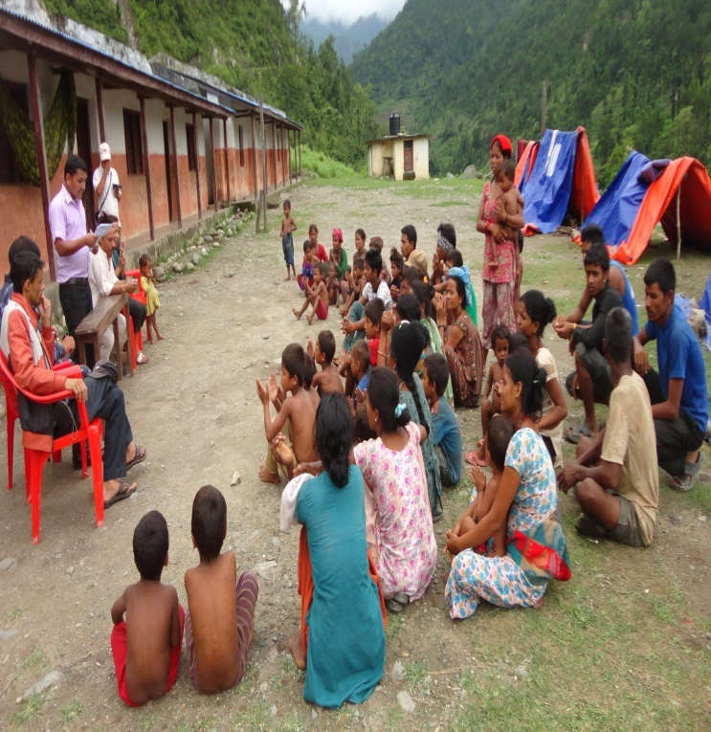
@=! b}n]v cfGbf]ng @)^( M
b}n]vsf o'jf cleoGtf lxSdt axfb'/ afbLsf] cu'jfO{df b}n]v lhNnfsf afbL ;d'bfon] klxnf] k6s @)^( ;fndf b}n]v lhNnfsf] ;b/d'sfddf wgf{ ;lxtsf] cfGbf]ng u/]sf lyP . o; cfGbf]ngdf b}n]v lhNnf e/Laf6 s/La %)) hgf ;xefuL ePsf lyP / pQm cfGbf]ng $ lbg ;Dd rn]sf] lyof] . o; cfGbf]ng af6 lgdg cg';f/sf pknlAwx? k|fKt ePsf lyP .

pknlAwx?
!= b}n]v lhNnfsf afbL ;d'bfosf] ;d:ofx?af/] :yfgLo txdf hfgsf/L ePsf] 5 .
@= b}n]v lhNnfsf afbL ;d'bfon] ef]Ug' k/]sf ;d:ofx?sf] ;+ul7t ?kdf cfjfh p7]sf] / /fHo kIfaf6 b}n]vsf afbL ;d'bfosf] kIfdf sfd ug]{ k|lta4tf hfx]/ ePsf] 5 .
#= cfGbf]ngsf] k|efjsf sf/0f b}n]v lhNnfdf afbL ;d'bfosf] @ j6f gd'gf a:tL lgdf{0f ePsf 5g\ .
$= cfGbf]ng kZrft b}n]v lhNndf /fHosf] tkm{af6 $$ kl/jf/n] cfjf;sf] nflu 3/ cg'bfg k|fKt u/]sf 5g\ .
%= cfGbf]ng kZrft :yfgLo txsf] tkm{af6 afbL ;d'bfonfO{ vfBfGg tyf cGo ;xof]u pknAw u/fPsf] lyof] .

@=@ ;+/If0f tyf z}lIfs ;xof]u cleofg
@)^% lt/ b}n]v lhNnfsf afbL ;d'bfosf] nflu sfd ug]{ s'g} klg ;+3 ;+:yfx? lyPgg . u/LaLsf sf/0f b}n]v lhNnfsf clwsf+z afnaflnsfx? 3/]n' sfdbf/ tyf ;8s afnaflnsfsf] ?kdf /x]sf lyP . afnaflnsfx?sf] z}lIfs cj:yfnfO{ dWo gh/ ub}{ lxSdt afbLn] laleGg lgsfox?;+u ;dGjo ;Dks{ u/L b}n]v lhNnfsf u/La kl/jf/sf !)) eGbf al9 afnaflnsfx?nfO{ sf7df08f}+df a:g] tyf k9fO{sf] Aoj:yfkg ul/lbPsf lyP .

@=# gd'gf a:tL lgdf{0f
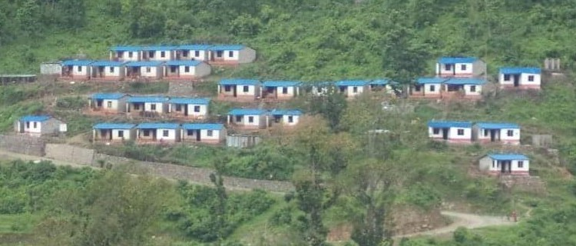
- tNnf] 8'Ë]Zj/ gd'gf a:tLM @)^( ;fn ;Dd b}n]vsf] tNnf] 8'Ë]Zj/df /x]sf] s0ff{nL gbLsf] lsgf/df afbL a:tL lyof] . @)^( ebf} dlxgfdf cfPsf] af9Ln] glbsf] lsgf/df /x]sf afbL ;d'bfosf ;a} 3/x? gbLn] aufof] . af9Lsf sf/0f 3/af/ lalxg ePsf afbL kl/jf/x? Psh'6 eO{ b}n]v lhNnfsf] ;b/d'sfddf /x]sf] ;}lgs SofDksf] 5]pdf kfn 6f+u/ @ lbg ;Dd a;] . ;+s6sfnsf] ;dodf ;f] c:yfO{ a:tLnfO{ ;}lgs kIfaf6 x6fpg vf]h] kl5 b}n]v lhNnfsf tTsflng k|d'v lhNnf clwsf/Lsf] ;xhLs/0fdf afbL ;d'bfosf AolQmx?nfO{ b}n]v ahf/df /xsf] Pp6f ;/sf/L laBfnosf] k|fË0fdf csf]{ Aoj:yf gx'Gh]n ;Ddsf nflu vfg] Aoj:yf ;lxt c:yfoL ?kdf a:g] Aoj:yf ul/of] . lxSdt axfb'/ afbL kxndf c:yfoL 6x/fdf a;]sf kl/jf/x?sf nflu tNnf] 8'Ë]Zj/sf] Pp6f 8f8f vl/b u/L zx/L l8lahg sfof{non] hgtf cfjf; sfo{qmd cGtu{t $$ j6f kl/jf/sf] nflu k|lt kl/jf/ l6gsf] 5fgf ePsf] @ sf]7fsf] kSsL 3/ lgdf{0f u/L b}n]v ahf/df c:yfoL ?kdf a;]sf afbL kl/jf/nfO{ x:tfGt/0f ul/of] .
tNnf] 8'Ë]Zj/sf] gd'gf a:tL

@=$ lxSdt xf]:6]n ;+rfng, afbL ;/f]sf/ d+rsf] :yfkgf / kfl/jfl/s k'g{ldngM
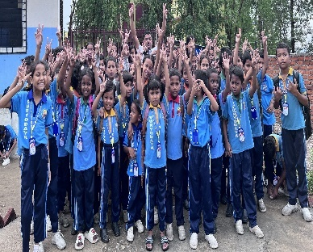
- lxSdt xf]:6nM afbL ;d'bfosf] afnaflnsfx?sf] z}lIfs cj:yfnfO{ dWogh/ ub}{ lxSdt axfb'/ afbLn] @)&# ;fndf !^ hgf cgfy c;fxo aflnsfx?af6 lxSdt xf]:6]n gfds afn ;+/If0f u[x z'? u/]sf lyP . laleGg sl7gfO{sf afah'b klg s]xL dgsf/L ;dfh;]jLx?sf] ;xof]uaf6 afnalnsfx?nfO{ ;'/lIft cfjf;, vfgf tyf lzIffdf ;xof]u pknAw u/fpb} cfPsf 5g\ . ;flassf] lxSdt xf]:6]n xfn afn ;+/If0f s]Gb| -5fqaf;_ gfdaf6 ;+rflnt 5 . o; 5fqaf;df !@^ hgf -5fqf &@, 5fq %$_ afnaflnsfx? /x]sf 5g\ . -afn ;+/If0f u[xsf afnaflnsfx?sf] la:t[t laj/0f cg';"lr ! df x]g'{xf]nf_
afbL ;/f]sf/ d+r g]kfnaf6 ;+/lIft afnaflnsfx?

- afbL ;/f]sf/ d+rsf] :yfkgf M afn ;+/If0f s]Gb| -5fqaf;_ nfO{ ;+:yfut ?kdf ;+rfng ug{ / cNk;+Vos, l;dfGts[t tyf ;'lawf lalxg ;d'bfox?df ;fd'bflos lasf;sf sfdx? ;+rfng ug]{ pb]Zo /flv afn ;+/If0f sfo{df ;+nUg lxSdt axfb'/ afbL nufot afbL ;d'bfosf cGo o'jfx?n] @)&* ;fndf afbL ;/f]sf/ d+r gfds u}/;/sf/L ;+:yf :yfkgf u/]sf 5g\ . @)&# ;fndf !% hgf aflnsf ;lxt lxSdt xf]:6]nsf] gfdaf6 z'? ul/Psf] z}lIfs cleofg xfn cfP/ ;+:yfut ?kdf cuf9L al9 /x]sf] 5 .
- kfl/jfl/s k'g{ldng M afbL ;d'bfosf c;fxo, cgfy tyf ;'lawf lalxg afnaflnsfx?nfO{ ;'/lIft cfjf;, lhag pkof]uL lzIff ;lxt u'0f:t/Lo lzIff, afnaflnsfx?sf] zfl//Ls, dfgl;s tyf ;+j]ufTds lasf;, Aoj;flos ;Lkd'ns tflnd lbO{ bIf tyf k|lt:klw hgzlQm tof/ ug]{ pb]Zosf ;fy afbL ;/f]sf/ d+r g]kfnn] @)&# ;fn b]lv afn ;+/If0f s]Gb| -5fqaf;_ ;+rfng ub}{ cfPsf] 5 . 5fqaf;df a;L cWoog k'/f ul/ ;s]sf jf cWoognfO{ lg/Gt/tf lbg g;sL cltl/Qm ;Lk xfl;n u/L lhaLsf]kfh{g ug{ ;Ifd ePsf o'jfx?nfO{ afbL ;/f]sf/ d+r g]kfnn] pgLx? Kl/jf/;+u k'g{ldng u/fpg] ub{5 . o; cjlwdf afbL ;/f]sf/ d+r g]kfnn] !% hgf afnaflnsfx?nfO{ pgLx?sf] kl/jf/;+u k'g{ldng u/fpg ;kmn ePsf] 5 . kfl/jfl/s k'g{ldng ul/Psf afnaflnsfx? o; k|sf/ /x]sf 5g\ .

qm=;+= | gfd | lnË | 7]ufgf | xfnsf] cj:yf | s}lkmot
! | sdnf afbL | dlxnf | b}n]v | laafx ePsf]
@ | ;l/gf afbL | dlxnf | ?s'd | kl/jf/;+u a;]sf]
# | u'/f+; afbL | dlxnf | b}n]v | laafx ePsf]
$ | lzvf afbL | dlxnf | b}n]v | a}b]lzs /f]huf/L
% | b'uf{ afbL | dlxnf | b}n]v | a}b]lzs /f]huf/L
^ | ;Gh' afbL | dlxnf | b}n]v | laafx ePsf]
& | sdnf afbL | dlxnf | b}n]v | laafx ePsf]
* | ;+lutf afbL | dlxnf | b}n]v | laafx ePsf]
( | dlgzf afbL | dlxnf | c5fd | laafx ePsf]
!) | glag afbL | k'?if | Hffh/sf]6 | kl/jf/;+u a;]sf]
!! | lagf]b afbL | k'?if | b}n]v | kl/jf/;+u a;]sf]
!@ | laa]s afbL | k'?if | b}n]v | kl/jf/;+u a;]sf]
!# | cldt afbL | k'?if | b}n]v | kl/jf/;+u a;]sf]
!$ | cGhnL afbL | dlxnf | b}n]v | kl/jf/;+u a;]sf]
!%

@=% ;'v]{t cfGbf]ng @)&& / pknlAwM
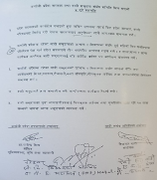
- cfjf; ;lxtsf] v]tLof]Uo hldg, /f]huff/sf] ;'lglZrttf nufot dfux? /fVb} afbL ;d'bfosf cleoGTff >L lxSdt axfb'/ afbLsf] cu'jfO{df afbL ;+3if{ ;ldtLn] la=;+= @)&& kmfu'g ( ut] b]lv @^ ut] ;Dd s0ff{nL k|b]z ;/sf/ d'VodGqL tyf dGqLkl/ifb sfof{nosf] cuf8Lsf] k|fË0fdf wgf{ ;lxtsf] bjfjd'ns cfGbf]ng ;3if{ u/]sf] lyof] . !& lbgsf] bafjd'ns cfGbf]ng kZrft s0ff{nL k|b]z ;/sf/ / afbL ;+3if{ ;ldtL lar @)&& kmfu'g @& ut] % a'b] lnlvt ;Demf}tf ePsf] lyof] .

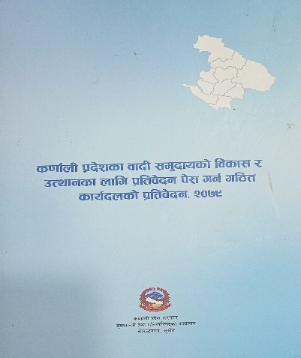
- afbL ;d'bfosf] cWoog / k|lta]bg k|sfzg M % a'b] ;xdltsf] @ g+= a'bfdf s0ff{nL k|b]zdf /x]sf afbL ;d'bfosf] pTyfg / lasf;sf nflu b'O{ dlxgf leq oyft{k/s k|lta]bg k]z ug{ s0ff{nL k|b]z ;/sf/n] tLg ;b:oLo sfo{bn u7g ug]{ egL ePsf] ;xdltnfO{ sfof{Gjog ug{ ldlt @)&( ciff9 !% ut] s0ff{nL k|b]z ;/sf/, d'VodGqL tyf dGqLkl/ifb sfof{no, zf;lso ;'wf/ dxfzfvfsf ;lrj >L cfgGb ;f? Ho'sf] ;+of]hsTjdf % ;b:oLo cWoog sfo{bn u7g eof] . pQm sfo{bnn] s0ff{nL k|b]z nufot cGo k|b]zsf afbL ;d'bfosf !) j6f a:tLdf cGt/s[of u/L ;'emfj tyf lgisif{ ;lxtsf] Ps k|lta]bg tof/ ePsf] 5 . of] k|lta]bg tof/L sfo{bn afbL ;/f]sf/ d+r g]kfnsf tkm{af6 lxSdt afbL / ;+:yfsf ;b:o ;'lgtf afbL ;b:osf] ?kdf /x]sf lyof] . of] cWoog k|lta]bg s0ff{nL k|b]zsf afbL ;d'bfosf] >f]t b:tfj]hsf] ?kdf /x]sf] 5 .

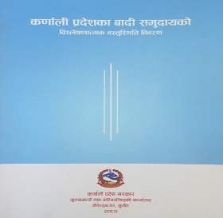
- afbL k|f]kmfO{n tof/LM cWoog sfo{bnn] k]z u/]sf] k|lta]bgdf u/]sf l;kmfl/;x?sf] sfof{Gjosf nflu s0ff{nL k|b]z ;/sf/ d'VodGqL tyf dGqLkl/ifb sfof{nosf] ;dGjo, UNDP-EUSIF sf] cfly{s ;xof]udf afbL ;/f]sf/ d+r g]kfnn] s0ff{nL k|b]zsf afbL ;d'bfosf] hg;+Vof ;lxtsf] vl08s[t tYofÍ ;+sng u/L laZn]if0ffTds a:t'l:ylt laj/0f -afbL ;f'bfosf] k|f]kmfO{n_ tof/ u/]sf] 5 .

@=^ hUuf k|flKt / ef}lts ;+/rgf lgdf{0f M
afbL ;/f]sf/ d+r g]kfn cGtu{t ;+/lIft afnaflnsfx?sf] :yfoL cfjf; lgdf{0fsf] nflu aL/]Gb|gu/ gu/kflnn] cfkm\gf] :jfldTjdf /x]sf] ;/sf/L hUuf dWo * s7\7f hUuf afbL ;f]sf/ d+r g]kfnnfO{ ejg lgdf{0fsf nflu x:tfGt/0f u/]sf] 5 . o;} u/L s0ff{nL k|b]z ;/sf/ ;dflhs lasf; dGqfnon] ejg lgdf{0fsf nflu ?= %) nfv pknAw u/fPsf] lyof] . ;fdflhs lasf; dGqfnoaf6 pknAwaf6 afbL ;/f]sf/ d+r g]kfnn] 5fq tyf 5fqfx?sf nflu * sf]7fsf] cfjf; ejg ! jf6, vfgf xn ;lxtsf] # sf]7fsf] efG;f 3/, l;sfO{ xn, # sf]7fsf] cleefjs 3/, @ sf]7fsf] sfof{no ejg, !@ j6f zf}rfnox? lgdf{0f u/]sf] 5 .
afbL ;/f]sf/ d+r g]kfn4f/f lgld{t ef}lts ;+/rgfx?

@=& /fxt ;xof]u M
@)*) sflt{s !& ut] z's|af/ dWo/ftdf hfh/sf]6sf] af/]sf]6 s]Gb| laGb' agfP/ ^=$ DofulgRo'6sf] e'sDk uPsf] lyof] . laleGg >f]tsf cg';f/ o; e'sDkaf6 hfh/sf]6 / klZrd ?s'ddf %% xhf/ kl/jf/ 3/af/ lalxg ePsf 5g\ lyP eg] s/f]8f}sf] ef}lts ;Dkltsf] Iflt ePsf] 5 . lala;L g]kfnL ;]jfsf cg';f/ e'sDk k|efljt If]qdf lr;f] tyf cGo sf/0fx?af6 !%& hgfsf] d[To' ePsf lyP . d[To' x'g]x?df ! dlxg] b'w] afns b]lv *( aif{ ;Ddsf a[4x? /x]sf 5g\ . e'sDk k|efljt If]qsf clwsf+z :s'nx?df ePsf] ef}lts Ifltsf sf/0f afnaflnsfx?sf] k7g kf7gdf ca/f]w lyof] . e'sDk k|efljt If]qsf afnaflnsfx?sf] cj:yfnfO{ dWo gh/ u/L afbL ;/f]sf/ d+r g]kfnn] e'sDk k|efljt If]qsf e'sDk k|efljt afbL ;d'bfosf *) kl/jf/x?nfO{ cfktsflng ;xof]u pknAw u/fPsf] lyof] .

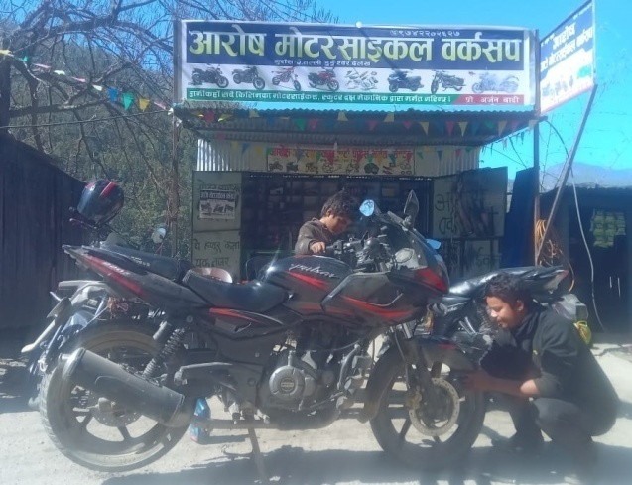
@=* lzIff tyf cfocfh{g ;xof]u sfo{qmdM
Stichting Nepal, The Netheland sf] cfly{s ;xof]u tyf World Vision Advocacy Forum (WVAF) sf] ;xsfo{df afbL ;/f]sf/ d+r g]kfnn] ;g @)@$ df b}n]v tyf ;'v]{t lhNnfsf afbL ;d'bfodf lhaLsf]kfh{g ;xof]u dfkm{t cfly{s z;lQms/0f sfo{qmd ;+rfng u/]sf] lyof] . o; sfo{qmd dfkm{t b}n]v lhNnfsf @ j6f o'jfx?nfO{ df]6/;fO{sn js{;k, ;'v]{tsf] dl;gfdf @ j6f kl/j/nfO{ afv|fkfng / ;'v]{t ahf/df ! kl/jf/nfO{ 7]nfuf8f ;lxt kmnkm"n tyf ls/fgf k;n ;+rfngsf nflu cfly{s ;xof]u pknAw u/fPsf] lyof] . o;sf ;fy} afbL ;/f]sf/ d+r g]kfn cGtu{t ;+/lIft afnaflnafx?nfO{ vfBfGg tyf cGo cfaZos ;xof]u pknAw u/fO{Psf] lyof] . Stichting Nepal, The Netheland n] cfocfh{g, vfBfGg tyf cGo cfaZos ;xof]usf] nflu hDdf ?= $,($,))) cIf/]kL rf/ nfv rf}/fgAa] xhf/ dfq cfly{s ;xof]u pknAw u/fPsf] lyof] .
b}n]vsf] tNnf] 8'Ë]Zj/df ;+rflnt df]6/;fO{sn js{;k

#= ;+:yfut lasf; / ;DaGw la:tf/M

#=! ;+:yfut Aoj:yfkg / hgzlQm kl/rfng M @)&# ;fndf !^ hgf afnaflnsf /flv lxSdt xf]:6]n gfds afn ;+/If0f sfo{af6 z'? ePsf] ;fdflhs lasf;sf] cleofgn] @)*! ;Dd cfO{ k'Ubf laleGg r/0fx? Kf/ ub}{ ;+:yfut ?kdf ;'b[9 x'b} uO{/x]sf] 5 . clxn] afbL ;/f]sf/ d+r g]kfnsf] cfkm\g} 5'6\6} sfof{no :yfkgf ePsf] 5 . ;+:yf b}lgs k|zf;g sfo{ Aojl:yt ?kdf ;+rfng ul//x]sf] 5 . xfn o; ;+:yfdf ;fdflhs If]qdf nfdf] ;do sfd u/]sf cg'ejL sd{rf/Lx?n] sfd ul//x]sf 5g\ .

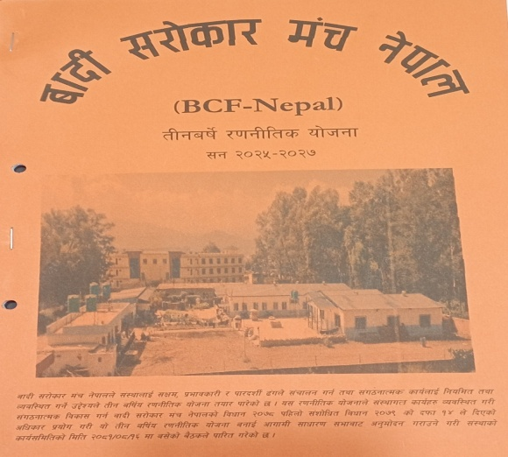
#=@ b:tfj]hLs/0fM s'g} ;+:yf jf lgsfosf] k|efjsf/L Aoj:yfkg To;sf] ;+:yfut b:tfj]hx?af6 emlNsG5 . o; cjlwdf afbL ;/f]sf/ d+r g]kfnn] ;+:yfnfO{ Aojl:yt tyf k|efjsf/L ?kdf ;+rfng ug{sf nflu ;+:yf tyf sfo{qmd ;+rfngsf nflu cfaZos b:tfj]hx? ;+:yfsf] klxnf] # aif]{ /0fgLlt of]hgf @)@%-@)@&, ;+:yfsf] cfly{s k|zf;g lgodfjnL @)*!, ;+:yfsf] sd{rf/L k|zf;g lgodfjnL @)*!, ;+:yf ;+rfng lgb]{lzsf @)*!, ;+:yfsf] cfrf/ ;lxtf @)*!, afn ;+/If0f gLlt tyf ;+rfng lgb]{lzsf @)*!, afn ;+/if0f s]Gb| -5fqaf;_ ;+rfng sfo{lalw @)*!, ;+:yfsf] n}lËs ;dfgtf tyf ;dfa]zLs/0f gLlt @)*! Tyf ;+:yfsf] ;+u7gfTds, laefluo tyf sd{rf/L Aoj:yfkg tyf kl/rfng ;+/rgfx? tof/ u/L ;f]xL cg';f/ nfu' ul/x]sf] 5 .

#=# ;"rgf k|lalwM afbL ;/f]sf/ d+r g]kfnnfO{ cem al9 Aoj;flos, k|lt:kwL{, kf/blz{ agfpg ;+:yfn] cfkm\gf] 5'6\6} www.bsmn.org gfds ;++rf/ ;+hfn -website_, afbL ;/f]sf/ d+r g]kfn gfds face book, Badi Sarokar Manch Nepal gfds Instragram, BSMN gfds X handle, bsmn2078@bsmn.org gfds, email ID k|of]udf NofPsf] 5 .

#=$ ;fem]bf/L M afbL ;/f]sf/ d+r g]kfnn] lgDg lgsfox?;+u ;fem]bf/L ;DkGg u/]sf] 5 .


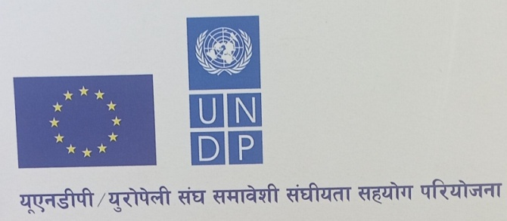
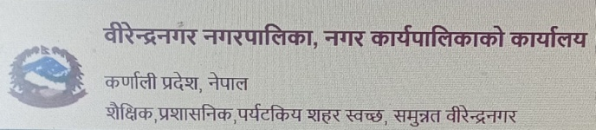
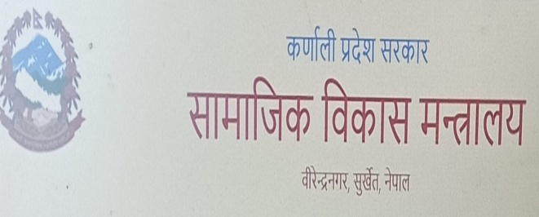
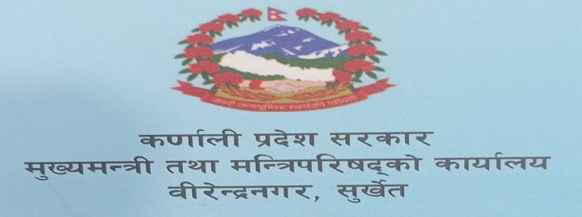




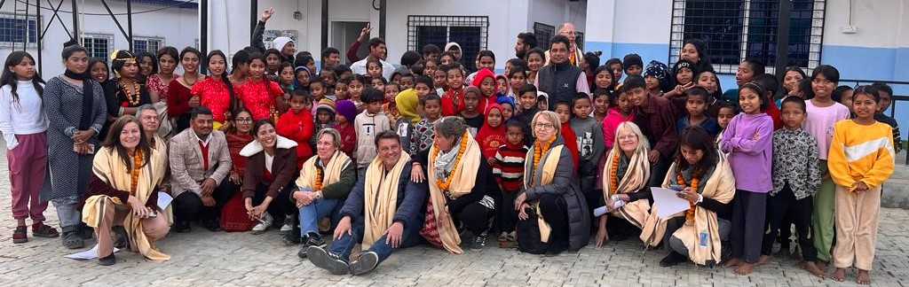
- gof+ ;DaGw la:tf/M o; cjlwdf afbL ;/f]sf/ d+r g]kfndf y'k|} lgsfo tyf AolQmx?af6 ;+:yfut tyf sfo{qmdut lelh6 ePsf 5g\ . o; cjlwdf ePsf lelh6x?df European Union, Delegation of the European Union to Nepal, Nepal Secretariat of Skill and Training sf k|ltgLlwx?;+usf] 5nkmn lgs} dxTjk'0f{ /x\of] . lo b'a} lgsfox?;+u lgs6 elaZodf g} ;fem]bf/Lsf] ;Defjgf ;lxt ;DaGw la:tf/ x'b} uO{ /x]sf] 5 . o;} u/L Stichting Nepal, The Netheland / World Vision Advocacy Forum, WILDE GANZEN Foundation ;+u @)@% af6 lb3{sflng ;fem]bf/L z'? ePsf] 5
EU /fhb't nufot o'/f]k l6dsf k|ltgLlwx?sf] ;'v]{t lelh6
$= ;dli6ut pknlAwx?
afbL ;/f]sf/ d+r g]kfnaf6 o; cjlwdf #(& hgf h;df dlxnf @(& / !!* hgf k'?ifx? nfeflGjt ePsf 5g\ . nfeu|flxx?sf] laj/0f o; k|sf/ /x]sf] 5 .

- Affn ;+/If0f sfo{qmd
  - 5fqaf;df a:g] hDdf afnaflnsf !@^ hgf -5fqf &@, 5fq %$_
  - Kfl/jfl/s k'g{ldng ePsf !^ hgf -5fqf !), 5fq ^_

- e'sDk lkl8tx?nfO{ /fxt ;xof]u
  - *) kl/jf/

- z}lIfs ;xof]u
  - hDdf !#^ hgf laBfyL{ -5fqf *^, 5fq %)_
- lhlasf] kfh{gsf nflu cfocfh{g ;xof]u
  - ;Lkd"ns tflnd # hgf dlxnf
  - df]6/;fO{sn Uof/]h ;xof]u @ hgf o'jf
  - afv|fkfng ;xof]u ^ kl/jf/
  - 7]nf uf8f ;lxt kmnkm"n tyf ls/fgf k;n ! kl/jf/

- Hf]lvd cj:yfsf ;8s afnaflnsfx?sf] p4f/
  - hDdf !@ hgf -5fqf ^, 5fq ^_

- :jf:Yo ;xof]u
  - !% hgf AolQm
%= ;xof]uL xftx?M
afbL ;/f]sf/ d+r g]kfn4f/f ;+rflnt ultlalwx?nfO{ ;+rfng ug{sf nflu laut b]lv ;+:yfut tyf AolQmut ?kdf cfly{s tyf a:t'ut ?kdf ;xof]ux? k|bfg k|bfg eO{ /x]sf 5g\ . ;g @)@$ ;Dd afbL ;/f]sf/ d+r g]kfnnfO{ cfly{s, ef}lts tyf a:t'ut ?kdf ;xof]u ug'{ePsf ;+:yfut tyf AolQmx?sf] ;"lr o; k|sf/ x/sf] 5 .
;+:yfut ;xof]u | AolQmut ;xof]u
s0ff{nL k|b]z ;/sf/ d'VodGqL tyf dGqL kl/ifbsf] sfof{no, ;'v]{t | >L odnfn s8]n, d'VodGqL, s0ff{nL k|b]z ;/sf/
s0ff{n k|b]z ;/sf/ ;fdflhs lasf; dGqfno, ;'v]{t | >L lhag axfb'/ zfxL, lgat{dfg d'VodGqL, s0ff{nL k|b]z ;/sf/
aL/]Gb|gu/ gu/kflnsf aL/]Gb|gu/ ;'v]{t | >L /fh s'df/ zdf{ lgat{dfg d'VodGqL, s0ff{nL k|b]z ;/sf/
Dffgj clwsf/ cfof]u | >L 6]s/fh k5fO{ lgat{dfg ;fdflhs lasf; dGqL, s0ff{nL k|b]z ;/sf/
* g+= j8f sfof{no aL/]Gb|gu/ gu/kflnsf, ;'v]{t | >L cfgGb ;f? ;lrj d'VodGqL tyf dGqL kl/ifbsf] sfof{no, ;'v]{t
Uropean Union (EU), Delegation of the Uropean Union to Nepal | >L, ;Gt axfb'/ ;'gf/ ;lrj ;fdflhs lasf; dGqfno, s0ff{nL k|b]z
Stichting Nepal, The NetherLand | 8f= >L gj/fh s]=;L=
Plan International | >L c?0f af:sf]6f -ck|af;L/Aofkf/L_
World Vision Advocacy Forum (WVAF) | >L clgtf 1jfnL, lghfdlt sd{rf/L_
Lions Club, Surkhet | >L laBf rfkfufO{, k|:tf]tf x]g]{ syf
INSEC, Surkhet | >L df]xg dfof 9sfn, d]o/ aL/]Gb|gu/ gu/kflnsf
;Dafb ;d'x s0ff{nL k|b]z | led pkfWofo, ;fdflhs cleoGtf
x]g]{ syf l6d | >L >L k|s[lt s]=;L=
;'of]{bo af]l8{Ë :s'n | >L cGh' ;dL sfsL{
l;BkfO{nf af]l8{Ë :s'n | >L, df]xg a8'jfn
piff sn]h | >L, gu]Gb| pkfWofo, kqsf/
df]8]n sn]h | >L, eb| e08f/L
;fpy Pl;og af]l8{Ë :s'n | >L, l6sf/fd rkfO{
O{G6/g]zgn af]l8{Ë :s'n | bz{s tyf >f]tfx?, x]g]{syf !)% O{lk;f]8
Anf]ldË dG6]Zj/L :s'n
Nff]6; dG6]Zj/L :s'n
Df]lg{Ë :6f/ af]l8{Ë :s'n
Ps Ps kfO{nf

^= efaL of]hgf/sfo{lbzf -Future-Direction_
@)^( ;fndf b}n]v lhNnfsf afbL ;d'bfosf] Aojl:yt a;f]af; tyf lhlasf]kfh{gsf] cleofgaf6 yfngL ul/Psf] cgf}krfl/s ;fdflhs cleofg @)&# ;fndf lxSdt xf]:6]n afbL ;d'bfosf cgfy, c;fxo tyf ;'lawf lalxg afnaflnsfx?sf] ;+/If0f sfo{af6 cf}krfl/s ?kdf z'?cft ePsf] xf] . @)&* ;fndf of] cf}krfl/s cleofgn] afbL ;/f]sf/ d+r g]kfnsf] gfdaf6 ;+:yfut ?kdf ?kfGt/0f ePsf] 5 . @)*! ;fndf afbL ;/f]sf/ d+r g]kfnn] cfkm\gf] klxnf] ltg alif{o /0fgLlts of]hgf -;g @)@%-@)@&_ tof/ u/L ;+u7gfTds ?kdf cuf8L al9 /x]sf] 5 . ;+:yfsf] klxnf] tLg alif{o /0fgLlts of]hgf cg';f/sf] afbL ;/f]sf/ d+r g]kfnsf] efaL sfo{lbzf cGtu{t d'Vo d'Vo sfo{ lgDg cg';f/ /xg]5g\ .
- ;+u7gfTds la:tf/ M afbL ;/f]sf/ d+r g]kfn g]fknsf cNk;+Vos, l;dfGts[t, ;'lawf lalxg tyf kl5 kfl/Psf ;d'bfosf] ;fdflhs, cfly{s tyf /fhgLlts z;lQms/0f tyf d"nk|aflxs/0fsf nflu :yfkgf ePsf] 5 . l;ldt >f]t ;fwgsf] sf/0f ;g @)@$ ;Dd o; ;+:yfsf] pkl:ytL ;+u7gfTds ?kn] ;'v]{t lhNnfdf, nlIft ;d'bfosf] lx;fan] afbL ;d'bfo / nfeflGjt ;d'xsf] lx;fan] afnaflnsfx?df dfq l;ldt /x]sf] lyof] . ;+:yfsf] tLg aif]{ /0fgLlts of]hgf cGtu{t ;'v]{t lhNnfdf s]Gb|Lo sfof{no agfO{, lgs6 elaZodf ;+l3o /fhwfgL sf7df08f}+df ;Dks{ sfof{no :yfkgf ug]{5 . ;+:yfn] s0ff{nL k|b]z nufot ;'b'/ klZrd, n'lDagL k|b]zdf afbL ;d'bfo ;lxt blnt, cNk;+Vos, l;dfGts[t, ;'lawf lalxg tyf kl5 kfl/Psf ;d'bfosf afnaflnsf, dlxnf / o'jfx? dfem ;+u7g la:tf/ ub]{5 .

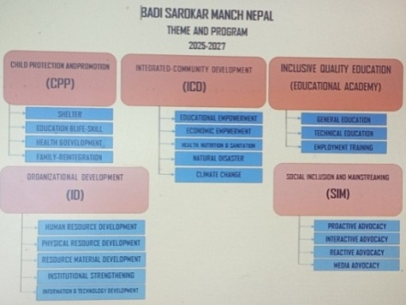
- sfo{qmdut la:tf/M ;g @)@$ ;Dd afbL ;/f]sf/ d+r g]kfnn] afn ;+/If0f sfo{qmd cGtu{t afn ;+/If0f s]Gb| -5fqfaf;_ sfo{qmddf s]Gb|Lt eO{ cfkm\gf ultlalwx? ;+rfng ub}{ cfPsf]df ;g @)@% b]lv ;+:yfn] % j6f d'Vo laifox? -Theme_ 5gf}6 u/L laleGg sfo{qmdx? ;+rfng ug]{ of]hgf cl3 ;f/]sf] 5 .

;g @)@% b]lv @)@& ;Ddsf nflu 5gf}6 u/LPsf d'Vo laifo tyf sfo{qmdx? o; k|sf/ /x]sf 5g\ .
d'Vo sfo{ | sfo{qmd
Affn ;+/If0f tyf k|a{wg | - ;'/lIft cfjf;  - lzIff / lhag pkof]uL ;Lk  - :jf:Yo / lasf;  - kfl/jfl/s k'g{ldng  - afn clwsf/ k|aw{g
Plss[t ;fd'bflos lasf; | - ;dflai6 lzIff  - lhlasf]kfh{g / cfocfh{g  - :jf:Yo, kf]if0f / ;/;kmfO{  - k|fs[lts k|sf]k / dfglao ;xfotf  - hnafo' cg's'ng / k|fs[lts lbuf]kgf
u'0ffTds lzIff / /f]huf/L | - cf}krfl/s lzIff  - Aoj;flos lzIff / ;Lk lasf; tflnd  - hflu/L s]Gb|Lt tflnd
;+:yfut lasf; | - hgzlQm lasf;  - ef}lts >f]t lasf;  - >f]t ;fdu|L lgdf0f{  - ;+u7gfTds ;jnLs/0f  - ;'rgf / k|lalwsf] lasf;
;fdflhs ;dfa]zLs/0f / d"nk|aflxs/0f | - gLltut k|efj  - kf/:kl/s ;+afb  - cWoog cg';Gwfg tyf b:tfj]hLs/0f  - ;+rf/ cleofg

- 5fqaf; Ao:yfkgM afn ;+/If0f s]Gb| -5fqaf;_ sfo{qmd afbL ;/f]sf/ d+r g]kfnsf] d]?b08 xf] . cfufdL lbgdf ;'v]{tdf /x]sf] 5fqaf;nfO{ afbL ;/f]sf/ d+r g]kfnn] afn ;+/If0f sfo{qmdsf] >f]q s]Gb|sf] ?kdf lasf; ub}5 . o;sf ;fy} lalaw sf/0fn] 5fqaf; ;+rfng ug'{kg]{ :yfgx?df ;+:yfn] cfaZostf cg';f/ yk 5fqaf;x? ;+rfng ub}{ hfg] 5 .

- gLlh lzIffno ;+rfng
  - :s'n ;+rfngM xfn ;fa{hlgs tyf gLlh laBfnox?af6 k|bfg ul/g] lzIff sfulh pkflw lng] / lzlIft a]/f]huf/ pTkfbg ug]{ vfnsf] 5 . dWod tyf lgDg alu{o kl/jf/sf afnaflnsfx? nflu xfnsf] z}lIfs k|0ffnL lhag pkof]uL b]lvb}g\ . t;y{ afbL;f]sf/ d+r g]kfnn] lgs6 elaZodf g} ;dliut z}lIfs Aoj:yfkg ;lxtsf] cfkm\gf] 5'6\6} lsG8/ uf8{g b]lv pRr dfWolds tx -Child Care Center to +2 level_ ;Dd k9fO{ ul/g] :s'n ;+rfngdf Nofpg] tof/L ul//x]sf] 5 . o; :s'nsf] z}lIfs kf7\oqmx? ;/sf/L laBfno, gLlh laBfno, lhag pkof]uL lzIff nufot cltl/Qm cfwf/e"t Aoj;flos lzIff k|bfg ug]{ ul/ tof/ ul/g] 5 .

  - k|flalws lzIff tyf Aoj;flos ;Lkd'ns tflnd s]Gb| ;+rfngM pRr dfWolds tx kf; ul/ /f]huf/L tkm{ nfUg rfxg] o'jfx?, ;Lk xfl;n u/L /f]uf/Ldf nfUg rfxg] o'jf tyf dlxnfx?nfO{ Aoj;flos ;Lk k|bfg ug{ afbL ;/f]sf/ d+r g]kfnn] lzlIft tyf cl;lIft k|lzIfyL{x?nfO{ nlIft u/L /f]huf/Lsf] ;'lglZrttf ;lxtsf] Aoj;flos ;Lkd'ns tflnd s]Gb| ;+rfngdf Nofpg nfu]sf] 5 .
  - Gff]s/Ldf s]Gb|Lt tflnd ;+rfngM afbL ;/f]sf/ d+r g]kfnn] pRr dfWolds tx tyf pRr lzIff xfl;n u/L gf]s/Ldf nfUg rfxg] o'jfx?sf nflu gf]s/L s]Gb|Lt tflnd sIffx? h:t} lzIfs nfO{;]G; k|flKt sf]if{, lghfdlt sd{rf/L gf]s/L sf]if{, ;'/Iff lgsfo egf{ sf]if{, cfbL ;lxtsf] gf]s/Lsf nflu cfaZos kg]{ k'a{ sf]if{x? ;+rfng ug]{5 .
- >f]t s]Gb| ;+rfngM s0ff{nL k|b]z ;fdflhs, ;f+:s[lt, tyf h}las laljwtfn] ;';lHht /x]sf] ePtf klg ;'rgf k|lalwsf] lx;fjn] cem} klg k5fl8 g} /xsf] 5 . afbL ;/f]sf/ d+r g]kfn g]kfn clt g} k5fl8 kfl/Psf cNk;+Vos, l;dfGts[t tyf kl5 kfl/Psf ;d'bfo afbL, blnt nufotsf cGo ;'lawf lalxgx?sf nflu sfd ug]{ ;+:yf xf] . cGo ;d'bfosf] t'ngfdf dfly pNn]lvt ;d'bfo;+u ;DalGwt >f]t ;fdu|Lx?sf] cefj / ePsf >f]t ;fdu|Ldf ;a}sf] kx'r x'g ;Sb}g . t;y{ afbL ;/f]sf/ d+r g]kfnn] ;+:yfut k|of]hg ;lxt pNn]lvt ;d'bfosf] af/]df hfgsf/L lng rfxg] lgsfo tyf AolQmx?sf] ;xhtfsf] nflu Aojl:yt >f]t s]Gb| ;+rfngdf Nofpg] 5 .
- pBf]u Aoj;fo ;+rfngM ;+:yfut tyf sfo{qmd lbuf]kgf u}/;/sf/L ;+:yfx?sf nflu Ps r'gf}ltsf] laifo aGg uPsf] 5 . ;+:yf ;+rfngsf nflu afXo lgsfosf] clwstd e/ kg'{kg]{ cj:yf / lbuf]kgfsf] lb3{sflng of]hgfsf] cefjdf xfn ;Dd y'k|} ;+3 ;+:yfx? :yfkgf eO{ lg/Gt/ rnfodfg x'g ;ls/x]sf 5}gg\ . t;y{ afbL ;/f]sf/ d+r g]kfnn] cfkm'n] ;+rfng u/]sf] lb3{sflng dxTj /fVg] sfo{qmdx?sf] lbuf]kgfsf nflu cfaZostf cg';f/sf :yfgLo ;d'bfos} Aj:yfkgdf laleGg pBf]u Aoj;fox? ;+rfng ub}{ hfg]5 .

&= ;+:yfsf] ;+/rgf / lhDd]jf/L M
afbL ;/f]sf/ d+r g]kfnsf] las]Gb|Ls/0f gLlt cGtu{t ;+:yfsf] sfo{ k|efjsfl/tfsf nflu ;+u7gfTds, sfo{qmdut tyf sd{rf/L kl/rfng u/L # ls;Ldsf ;+/rgfx? v8f ul/Psf 5g\ . x/]s ;+/rgfsf] b]xfo adf]lhdsf] sfd st{Ao / clwsf/x? tf]lsPsf] 5 .;+/rgfx? cg';"lr @ df /flvPsf] 5 .

- ;+u7gfTds ;+/rgf
- ;fwf/0f ;ef M afbL ;/f]sf/ d+r g]kfnsf] lawfg @)&* klxnf] ;+zf]wg @)&( sf] kl/R5]b @ bkmf % pkbkmf ! adf]lhd Ps ;fwf/0f;ef /xg]5 . of] ;fwf/0f ;ef ;+:yfsf] pRr lgsfo x'g] 5 .
- ;+rfns ;ldtL MafbL ;/f]sf/ d+r g]kfnsf] @)&* klxnf] ;+zf]wg @)&( sf] kl/R5]b # bkmf !# pkbkmf ^ adf]lhd ;+rfns cWooIfsf] g]t[Tjdf % ;b:oLo Ps ;+rfns ;ldtL /x]sf] 5 . ;+:yfsf] afifL{s ;fwf/0f ;efsf] lg0f{osf] sfof{Gjogsf ;fy} ;+:yfsf] lawfgn] tf]s] adf]lhdsf] sfo{x? ;+rfng ug]{ of] ;ldtLsf] d'Vo lhDd]jf/L /xg]5 .
- ;Nnfxsf/ ;ldtLM afbL ;/f]sf/ d+r g]kfnsf] @)&* klxnf] ;+zf]wg @)&( sf] bkmf ( pkbkmf @ -ª_ adf]lhd cfaZstf cg';f/ ;+:yfnfO{ ;/;Nnfx k|bfg ug{ Ps ;Nnfxsf/ ;ldtL x'g]5 .
- sfo{qmd k|aw{g laefuM ;+:yfsf] lawfg cg';f/sf pb]Zox? k'/f ug{ laleGg lgsfox?af6 k|fKt sfo{qmdx?nfO{ Aoj:yfkg tyf ;+rfng ug{ ;+:yfdf sfo{qmd k|aw{g laefu /xg]5 .
- ;+u7gfTds lasf; laefuM afbL ;/f]sf/ d+r g]kfnsf] ;+:yfut lasf; / ;+:yf cGtu{t ;+:yf cGtu{t ul7t, ;fd'bflos ;+u7gx?, afbL ;/f]sf/ d+r g]kfn;+u ;xsfo{ ug]{ lalQo ;+u7g, hg;+u7gx?sf] ;+:yfut ;jnLs/0f sfo{sf] nflu ;+u7gfTds lasf; laefu /xg]5 .
- n]vf tyf k|zf;g laefuM ;+:yfsf] cfly{s, e08f/0f tyf k|zf;lgs sfo{x?nfO{ Aojl:yt ug{sf nflu ;+rfns ;ldtLsf] ;b:osf] g]t[Tjdf n]vf tyf k|zf;g laefu /xg]5 . of] laefu ;+:yfsf] cfly{s k|zf;g tyf sd{rf/L k|zf;g lgodfjnL cg';f/ kl/rfng ul/g]5 .
- ;fdf'bflos ;xof]u ;ldtL M ;d'bfo:t/sf sfo{qmd tyf cleofgx?nfO{ pgLx?s} ;lqmo ;xeflutf tyf g]t[Tjdf ;+rfng ug{sf nflu sfo{If]qsf x/]s ;d'bfodf Ps ;fd'bflos ;xof]u ;ldtL u7g ul/ kl/rfng ul/g]5 . of] ;ldtL n}lËs ;xeflutf tyf ;fdflhs ;dfa]zLs/0fsf] l;4fGt cg';f/ ;a{klIfo AolQmx?sf] ;xeflutfdf u7g x'g]5 . h;df ## k|ltzt dlxnf nufot o'jf, ckfË, h]i7 gful/s, t]>f] lnËLx?sf] k|ltgLlwTjnfO{ ;'lglZrt ul/g] 5 .

- sfo{qmdut ;+/rgf MafbL ;/f]sf/ d+r g]kfnn] cfkm\gf] klxnf] # aif]{ -;g @)@% b]lv @)@&_ /0fgLlt of]hgf cGtu{t ;+:yf4f/f ;+rfng ul/g] lgDg ultlalwx?nfO{ laifout sfo{qmdsf] ?kdf kl/lai6 u/]sf] 5 .
- afn ;+/If0f tyf k|a{wg M ;+:yf4f/f ;+rfng ul/g] afn ;+/If0f s]Gb| -5fqaf;_ ;+u ;Dalwt ultlalwx?nfO{ afn ;+/If0f tyf k|a{wg sfo{qmd cGtu{t /flvPsf] 5 . o; cGtu{t afnaflnsfx?sf nflu ;'/lIft cfjf;, lzIff / hLag pkof]uL ;Lk, :Jff:Yo lasf;, kfl/jfl/s k'g{ldng, afn clwsf/ k|a{wg h:tf s[ofsnfkx? ;+rfng ul/g] 5g\ .
- Plss[t ;fd'bflos lasf; M afbL;/f]sf/ d+r g]kfnn] ;d'bfosf] z;lQms/0f sf ;+u ;DalGwt ultlalwx?nfO{ Plss[t ;fd'bflos lasf; sfo{qmd cGtu{t /flvPsf] 5 . o; sfo{qmd cGtu{t ;d'bfo :t/df ;dflai6 lzIff, lhaLsf]kfh{g tyf cfDbfgL a[l4, :jf:Yo, kf]if0f / ;/;kmfO{, k|fs[lts laklQ / dfglao ;xfotf, hnafo' cg's'ng tyf jftfj/0fLo lbuf]kgf cfbL_ s[ofsnfkx? ;+rfng ul/g]5g\ .
- ;fdflhs ;dfa]zLs/0f / d"nk|aflxs/0fM afbL ;/f]sf/ d+r g]kfn cfjfh laxlxgx?sf] cfjfh xf] . g]kfndf cNk;+Vos, l;dfGts[t ;'lawf lalxg tyf tyf k5fl8 kfl/Psf ;d'bfo h:t} afbL, blnt, cGo ;fdflhs, ;f+:s[lts tyf /fhgLlts ?kdf k5fl8 kfl/Psf ;d'bfo, ;d'xx?sf] cfjfh ;e|fGt ;dfh tyf /fHo;+u k'Ug ;ls/x]sf] 5}g . t;y{ dfly pNn]lvt ;d'bfox?sf] cfjfhnfO{ ;DalGwt 7f+p ;Dd k'ufpgsf nflu ;+:yfdf ;fdflhs ;dfa]zLs/0f tyf d"nk|aflxs/0f sfo{qmdnfO{ d'Vo sfo{qmd cGtu{t /flvPsf] 5 . o; sfo{qmd cGtu{t gLltdf k|efj, cGt/s[ofTds ;+afb, cWoog cg';Gwfg tyf b:tfj]hLs/0f / ;+rf/ cleofg s[ofsnfkx? ;+rfng ul/g] 5g\ .
- u'0f:t/Lo lzIff / /f]huf/LM afnaflnsfx?sf nflu u'0f:t/Lo lzIff, o'jf tyf dlxnfx?sf nflu /f]huf/L afbL ;/f]sf/ d+r g]kfnsf] d'Vo ;/f]sf/sf] laifo xf] . sfo{If]qsf afnaflnsfx?nfO{ ;Ifd z;Qm tyf k|lt:klw{ agfpg, o'jf tyf dlxnfx?sf] cfDbfgLdf a[l4 u/fO{ ;Dd'Ggt ;dfh lgdf{0f ug{ ;+:yfn] u'0f:t/L lzIff tyf /f]huf/LnfO{ d'Vo sfo{qmdsf] ?kdf kl/eflift u/]sf] 5 . o; sfoqmd cGtu{t, cf}krfl/s lzIff, Aoj;flos ;Lk lasf;, gf]s/Ldf s]Gb|Lt tflnd >[Înf, s[ofsnfkx? ;+rfng ug]{5 .
- ;+:yfut lasf; M afbL ;/f]sf/ d+r g]kfnsf] ;+:yfut lasf; tyf ;d'bfo :t/df ul7t ;fd'bflos ;+u7gx?sf] ;jnLs/0f, clwsf/ k|flKtsf nflu ul7t hg;+u7g, ;d'xx?sf] k|efjsf/L kl/rfngsf nflu ;+:yfn] ;+:yfut lasf; sfo{nfO{;+:yfsf] Ps c+usf] ?kdf /fv]sf] 5 . o; sfo{qmd cGtu{t hgzlQm lasf;, ef}lts >f]tsf] lasf;, ;+:yfsf] tyf ;d'bfo;+u ;DalGwt >f]t ;fdu|Lx?sf] k|sfzg, ;+u7gfTds ;jnLs/0f, ;"rgf k|lalwsf] lasf; cfbL s[ofsnfkx? ;+rfng ul/g] 5g\ .

*= sd{rf/L Aoj:yfkg ;+/rgf M afbL ;/f]sf/ d+r g]kfnsf] sfo{qmdut, cfly{s, k|zf;lgs tyf ;f+u7lgs ultlalwx?nfO{ sfof{Gjog ug{sf nflu ;+:yfsf] sd{rf/L k|zf;lgs lgodfjnLsf] clwgdf /lx ;+rfns ;ldtLn] cfaZos sd{rf/Lx? lgo'Qm ul/ kl/rfng ug]{5 . ;+:yfdf ;xofuL ->]0fL lalxg_, sfof{no ;xfos -klxnf] >]0fL_, ;xfos clws[t -bf]>f] >]0fL_, clws[t -t]>f] >]0fL_, laefluo k|d'v -rf}yf] >]0fL_ / k|d'v sfo{sf/L clws[t -kf+rf} >]0fL_ sf sd{rf/Lx? /xg]5 . ;+rfns ;ldtLsf] cWoIf ;+:yf k|d'v / k|d'v sfo{sf/L clws[t sfof{no k|d'vsf] ?kdf /xg] 5g\ .

(= afbL ;/f]sf/ d+r g]kfnsf] hgzlQmx?

(=! sfo{sf/L ;ldtL
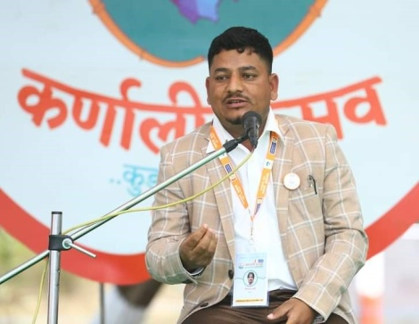

lxSdt axfb'/ afbL
s]Gb|Lo cWoIf

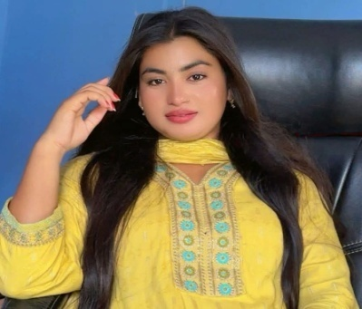
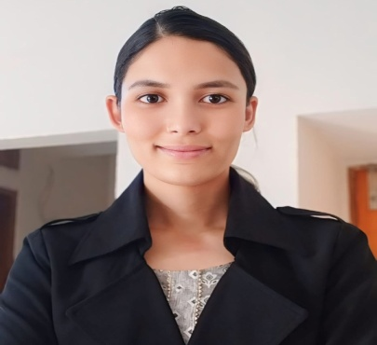
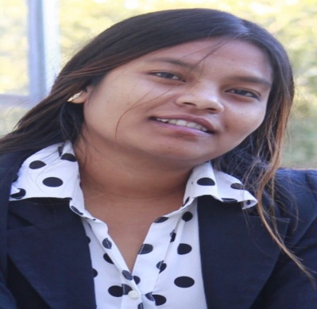
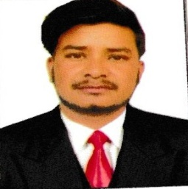
;'hgf afbL
s]Gb|Lo ;b:o

;'lgtf afbL
s]Gb|Lo ;b:o

k|sfz afbL
s]Gb|Lo ;b:o

cl:dtf afbL
s]Gb|Lo ;b:o

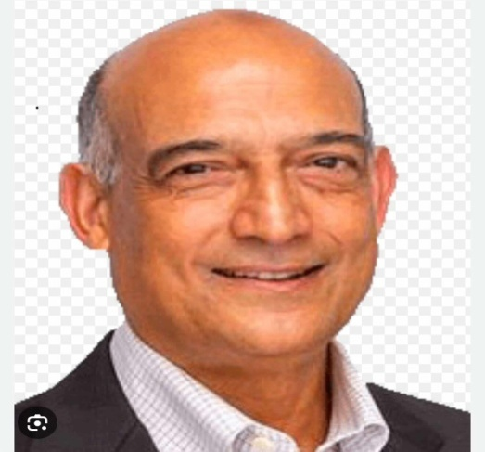
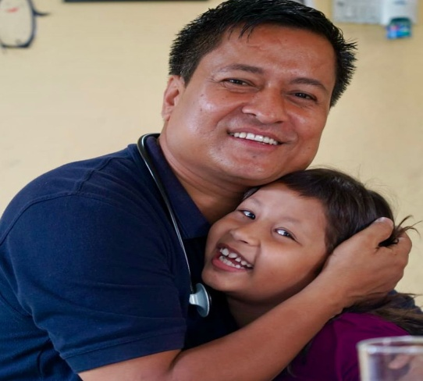
(=@ ;Nnfxsf/ ;ldtL
8f= >L gj/fh s];L
;+of]hs ;Nnfxsf/ ;ldtL
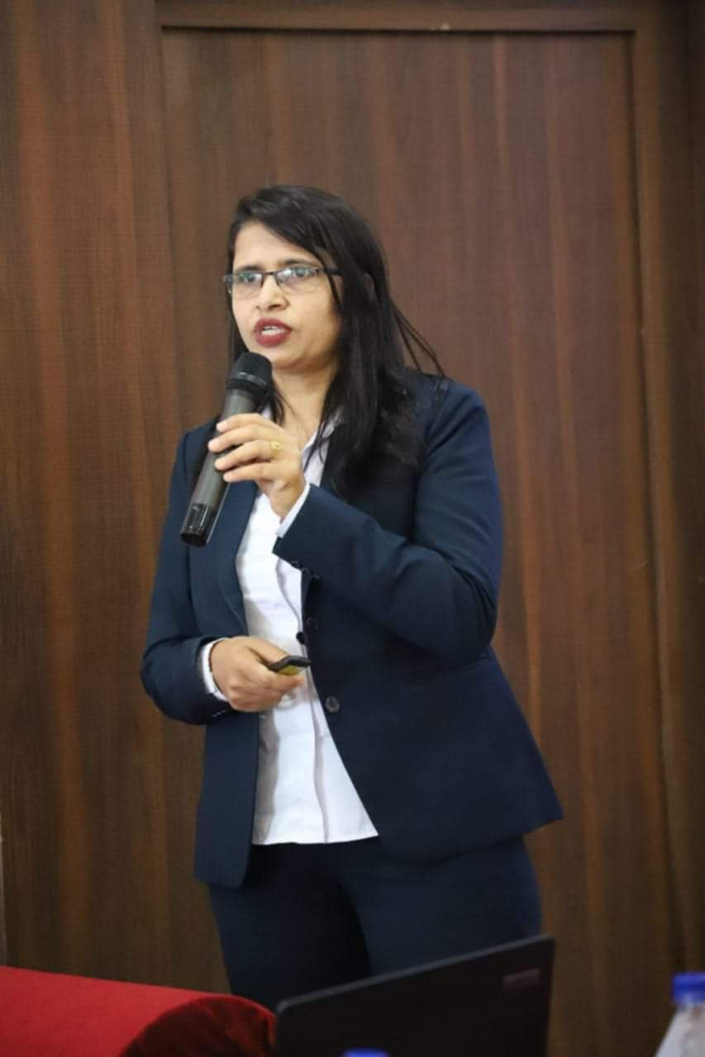
>L clgtf 1jfnL
;b:o ;Nnfxsf/ ;ldtL
>L c?0f af:sf]6f
;Nnfxsf/ ;ldtL ;b:o

(=# sd{rf/L tyf :jod;]js
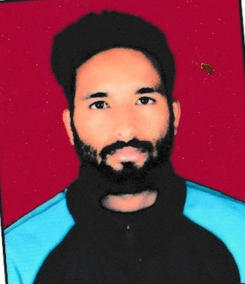
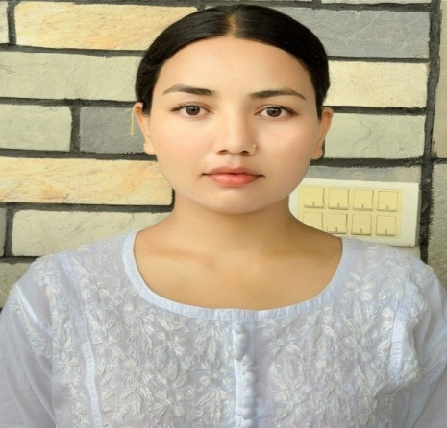
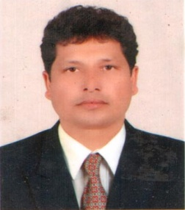
/fh' afbL
Afn ;+/If0f sfo{qmd clws[t
lbg]z afbL
sfof{no ;xof]uL
lg/h afbL
:jod;]js
lx/f afbL
;'/Iffuf8{
;+lutf afbL
xf]:6]n O{Grfh{
;'snfn g]kfnL
d'Vo sfo{sf/L clws[t

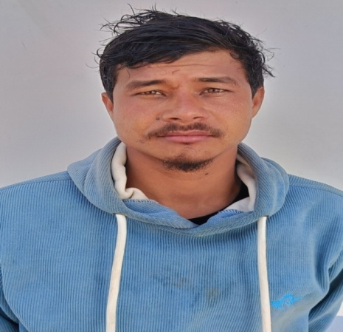
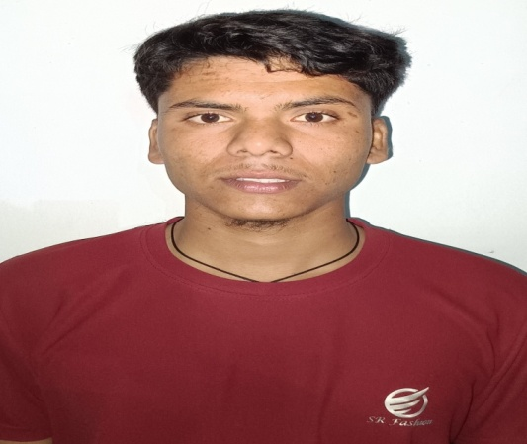
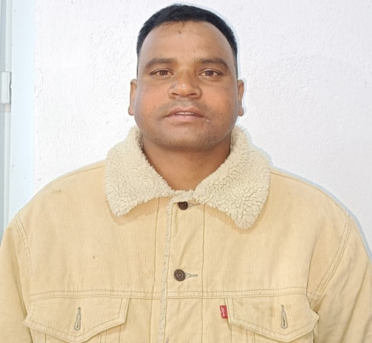

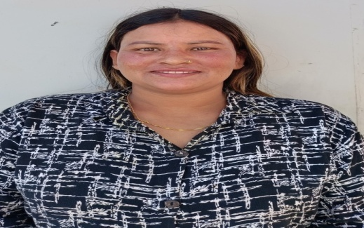
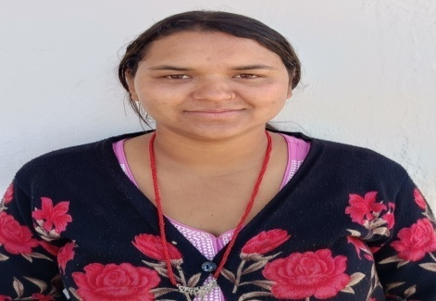

;[hgf afbL
efG;]
s[i0f uGbe{
efG;]
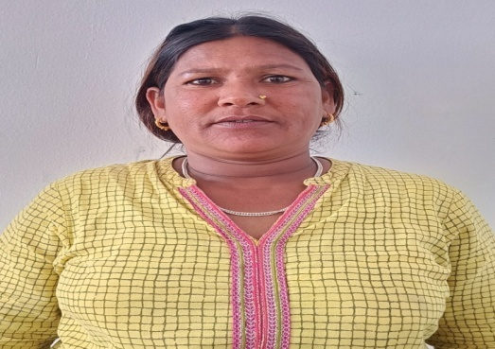
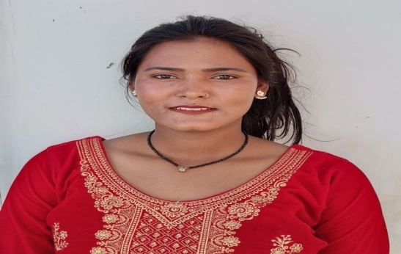

a;Gt afbL
;kmfO{stf{
;Gh' afbL
;kmfO{stf{

!)= afn k|ltef

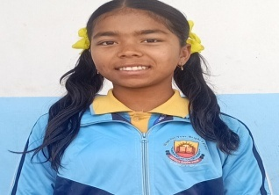
s[ltM slatf :yfgM afn;+/If0f u[x
k9fpg'eof] xh'/n] ;asf] kfp 5f]O{
eGg' gk/f]; xfdLn] xfd|f] bfO{ vf]O{
d]/f] x/]s cIf/df tkfO{sf] d]xgt x'G5
d]/f] of] X[bon] xhf/ ;kgf a'G5
xfdLn] tkfO{sf] ;kgfnfO{ ;fsf/ agfpg} k5{
xfdL xh'/sf] c+ufnf]df x'g}k5{
xh'/sf] xftaf6 rf]6 vfbf klg lg k5f8L g;/]sf]
xh'/n] cfkm\gf] pkrf/ lsg gu/]sf]
c?sf] cuf8L xft hf]8]sf] x]g{ dg 5}g
d slxn] klg tkfO{sf] s'/fdf k5f8L eO{g
cf]7 d]/f] zAb xh'/sf]
cIf/ d]/f] skL xh'/sf]
xft d]/f] snd xh'/sf]
elaZo d]/f] t/ d]xgt xh'/sf]

Plngf afbL sIff $

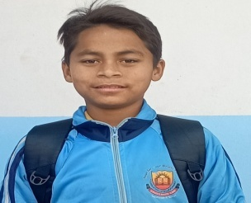
s[ltM slatf -wGoafb_ :yfgM afn;+/If0f u[x
dnfO{ ;fy lbg'eof] xh'/nfO{ wGoafb
dnfO{ k9fpg'eof], xh'/nfO{ wGoafb
cfh xh'/sf] hGdlbg xf] d}n] s]xL ug{ ;s]g
To;}n] xh'/nfO{ of] slatf n]v]sf]

d]/f] ;'v b'Mvdf ;fy lbg'eof] xh'/nfO{ wGoafb
dnfO{ dfof ug'{eof] dnfO{ cfkm\gf] agfpg'eof], xh'/nfO{ wGoafb

clxn] ;Dd d Psnf] eP/ a:g] lyP
t/ xh'/ cfP/ d]/f] lhGbuL /fd|f] agfO{lb'g eof], xh'/nfO{ wGoafb
;a}nfO{ cfkm\gf] sfwdf /fVg'eof] cfkm' /f]uL eP/ klg ;a}nfO{ k9fpg' eof], xh'/nfO{ wGoafb

slxn} klg slatf gn]Vg] dfG5] d
xh'/sf] r/0fdf cfP/ slatf n]Vg l;s], xh'nfO{ wGoafb

laho afbL, sIff $

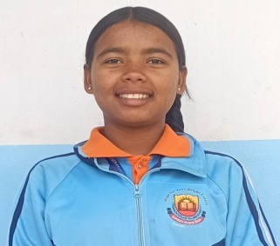
s[ltM lr7L :yfgM afn;+/If0f u[x
cfb/0fLo bfh'
;fb/ 9f]u

d oxf+ cf/fd} 5', Toxf+ tkfO{nfO{ klg 5 eGg] cfzf /fv]sL 5' . cfh tkfO{nfO{
d Pp6f 5f]6f] lr7\7L n]Vg uO{ /x]sL 5' . bfh' olb tkfO{n] dnfO{ afbL ;/f]sf/
d+r g]kfndf gNofPsf] eP dnfO{ clxn] tkfO{nfO{ lbg] lr7L n]Vg cfpg] lyPg / cIf/ klg lrGg ;Sy]g xf]nf . lsgls d]/f] 3/df slk snd lsGg] k};f g} 5}g, gt slk lstfa xfNg] emf]nf . ha d]/f] afaf cfdf a'9f] x'g'x'GYof], afafn] uf8Laf6 ;fdfg ptf/]/ cfPsf] k};fn] 3/kl/jf/nfO{ kfNg] ug'{ x'GYof] . d]/f] cfdf lu6\6L s'6\g] sfd ug'{x'GYof] . To; avt xfd|f] 3/df lgs} b'v lyof] . Ps k6s d]/f] afafnfO{ hl08; /f]u nfUof] . 3/df a'jfnfO{ cf}ifwL pkrf/ ug]{ k};f lyPg . cf}ifwL pkrf/ ug{ l9nf] eP/ d]/f] afafsf] d[To' eof] . afafsf] d[To' kl5 cfdfn] PSn}n] b'Mv u/]/ xfdL 5f]/f 5f]/Lsf] kfng kf]if0f ul/g .

uf+pdf /xbf c? laBfyL{x?n] laBfnodf 8]«; nfPsf] b]v]/ dnfO{ klg To:t} 8]«; nufP/ laBfno hfg dg nfUYof] . To; avt 8fS6/, kfO{n6, lzIfs eg]sf] s]xf] dnfO{ yfxf lyPg . ha bfh' ;dfhdf b'Mv si6 u/]/ 7'nf] dfG5] aGg' eof] clg xfd|f] s0ff{nL k|b]zsf k9]g gkfPsf b'MvL, u/La, lkl8tx? k9\nfg / 7'nf] dfG5] eP/ cfkm\gf cfdf a'jfsf] ;]jf unf{g, xfd|f] h:tf] b'Mv gxf]; eg]/ bfh'n] cfkm\g} ;+:yf vf]Ng' eof] . To; ;+:yf cGtu{t ;+rfng u/]sf] xf]:6]ndf dnfO{ klg Nofpg' eof] . dlg xf]:6]ndf a:g kfpbf w]/} v'zL eP/ / cfkm'nfO{ efUodfgL 7fg] . bfh'n] xf]:6]ndf NofO{ gof+ 8]«; h'Qf lsgL lbg'eof] / xfdL ;a}nfO{ :s'ndf egf{ klg ul/lbg' eof] .

lxSdt bfh'n] xfdL ;a}nfO{ xndf a;fn]/ xfdL cg'zf;gdf a:g'k5{ ca xfdL k9]/ 7'nf] dfG5] aGg'k5{ eGg'eof] . ha d}n] s'/f a'em\b} uP / k9\b} hfbf v]/L aNn a'em] ls k9fO{ eg]sf] 7"nf] s'/f /x]5 . k9fO{n] g} dfG5] 8fS6/, kfO{n6, jlsn ag]sf /x]5g eGg] a'em] . oL ;a} s'/f a'em] / d klg /fd|f] ;+u d]xgt u/]/ k9\5' / slxn} x/]z vfg x'Gg eg]/ hf]; hfu/ cfof] .

dnfO{ cfzf 5ls d}n] elaZodf s]xL u5'{ eGg] rfxgf 5 . ;a} eGbf klxnf cfkm' c;n eP eg] /fd|f] af6f]df nfUg ;lsG5 . To;}n] clxn] dnfO{ of] xf]:6]ndf a:g kfpbf, ;+:yf dfkm{t k9\g kfpbf dnfO{ eujfgn] gof+ lhag lbP h:t} nfU5 . of] gof+ lhagsf] nflu ;a{k|yd lxSdt bfh'nfO{ w]/} w]/} wGoafb lbg rfxG5' . xfd|f] nflu tkfO{ ;flRrs} eujfg ag]/ cfpg'eof] . bfh' slt dflg;x? k9\g, vfg gkfP/ kl5 k/]sf 5g\ . xh'/n] xfdLnfO{ o:tf] Aojl:yt u/]/ /fVg' ePsf] 5 . bfh' d tkfO{nfO{ nfvf} k6s wGoafb lbg rfxG5' . olt eGb} d]/f] snd olx aGb ug{ rfxG5' .

slt ;'Gg] csf{sf syf
d]/f] klg ;'lgb]p lhagsf Aoyf

wGoafb

k9fpg] kfpg]
sdnf afbL lxSdt axfb'/ afbL

sdnf afbL, sIff )&

!!= ;kmntfsf] syfx?

!!=! ablnPsf] lhagz}nL

sdhf]/ kfl/jfl/s cfly{s cj:yf tyf cleefjsx?sf] dlb/f ;]jg ug]{ afgLsf sf/0f b'Nn' gu/kflnsf j8fg+= )! tNnf] 8'Ë]Zj/ b}n]v afbL a:tLsf ef]hg afbL, ;'/]z afbL, glag afbL, dx]Gb| afbL, lazfn afbL / l6sf/fd afbLx?n] ;8s lhag latfO{ /x]sf lyP . pgLx?sf cleefjsx? clwsf+z ;do ef/tdf /f]huf/Lsf] nflu a:g] ub{y] . cleefjs eP/ klg cleefjs lalxg ePsf lo ^ hgf afnsx? clwsf+z ;do ;8sdf latfpg], nfu' cf}ifw ;]ag ug]{ tyf ;8sdf dfu]/ vfg] ub{y] . @)&^ ;fndf pgLx?nfO{ ;'v]{t lhNnfdf /x]sf] afn ;'wf/ u[xdf /flvPsf] lyof] . afn ;'wf/ u[xsf] sdhf]/ Aoj:yfkgsf sf/0f lo afnsx? ! dlxgf klg ga;L Toxf+af6 efuL ;'v]{t, sf7df08f}+, b}n]v nufotsf ahf/x?df k'gx ;8s lhag latfpg nfu] .

o;} qmddf @)&& ;fndf lo ^ hgf afnsx?nfO{ cleoGtf lxSdt axfb'/ afbLn] ;flas lxSdt xf]:6]ndf -xfn afbL ;/f]sf/ d+r g]kfn_ NofO{ pgLx?nfO{ ;+/If0f ug'{sf ;fy} ;'v]{tdf /x]sf laleGg lghL laBfnox?df egf{ u/L lzIff k|bfg u/fO{/x]sf 5g\ . o;sf cltl/Qm pgLx?n] ;+/If0f, lzIff, :jf:Yo ;]jfx? lgz'Ns ?kdf k|fKt ul//x]sf 5g\ . pgLx? eG5g, afbL ;/f]sf/ d+r g]kfn4f/f ;+rflnt afn ;/If0f s]Gb| -5fqaf;_ df a:g] cj;/ k|fKt ePsf sf/0f xfd|f] lautsf] cGwsf/do lhag xfn ;sf/fTs ?kdf km]/LPsf] 5 . ca xfdL w]/} k9]/ of]Uo gful/s aGg] 5f}+ eGg] cfzf /flv cuf8L kl9 /x]sf 5f}+ .

qm=;+= | afnssf] gfd | pd]/ | cWog/t laBfno | sIff | elaZosf] of]hgf
! | ef]hg afbL | ( | ;'of]{bo af]l8Ë :s'n | @ | k|x/L aGg]
@ | ;'/]z afbL | !@ | ;'of]{bo af]l8Ë :s'n | # | Uffos aGg]
# | glag afbL | !^ | c/gLsf] af]l8Ë :s'n | & | Uffos aGg]
$ | dx]Gb| afbL | !^ | c/gLsf] af]l8Ë :s'n | ^ | Uffos aGg]
% | lazfn afbL | !% | c/gLsf] af]l8Ë :s'n | ^ | 8S6/ aGg]
^ | l6sf/fd afbL | !@ | ;'of]{bo af]l8Ë :s'n | @ | 8S6/ aGg]
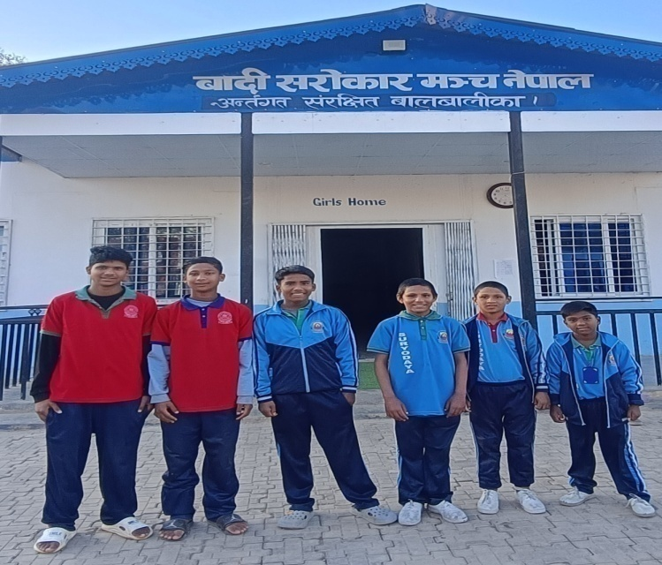
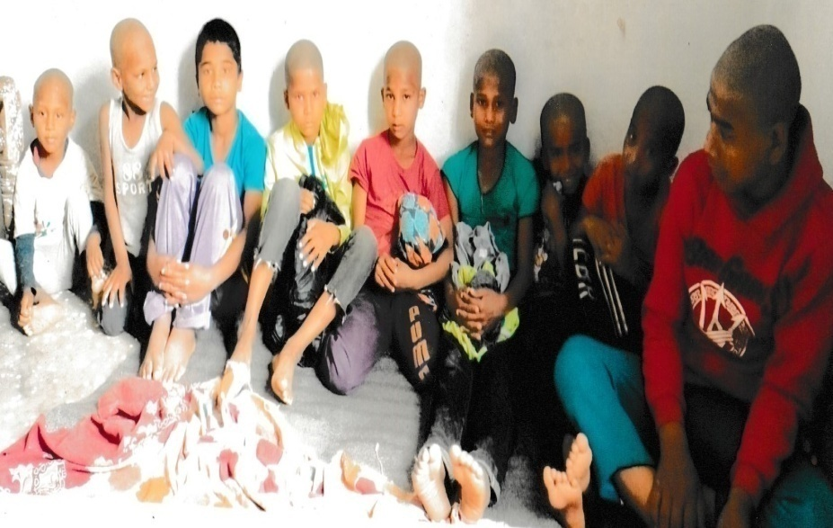
clxn]
afbL ;/f]sf/ d+r g]kfndf /xbfsf] cj:yf
@)&^ ;fndf afn ;'wf/ u[xdf /xbfsf] cj:yf
klxn]

!!=@ “cj;/ kfPdf xfdL klg /fd|f] sfd ug{ ;S5f}+”

!= k[i7e"ld M
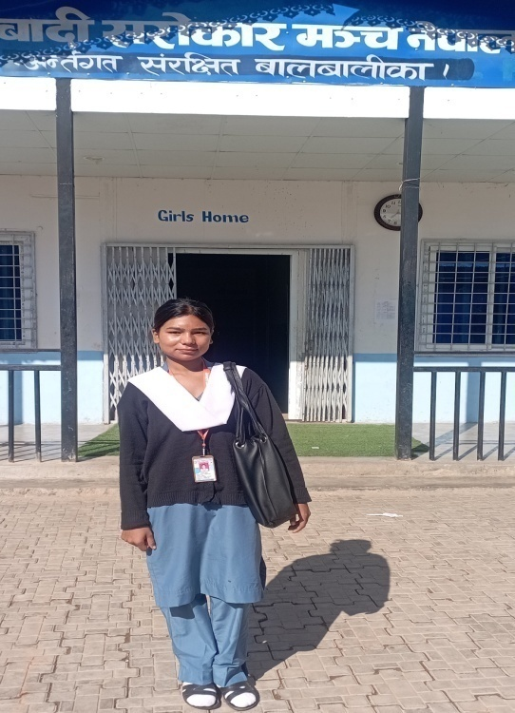
cfh eGbf !& aif{ cuf8L b'Nn' gu/kflnsf j8f g+= ! tNnf] 88'Ë]Zj/, b}n]vsf] afbL a:tLdf cfdf lkmgL afbL / a'jf uf]laGb afbL -xfn d[To'_ sf] bf]>f] ;Gtfg tyf h]7f] 5f]/Lsf] ?kdf k'hf afbLsf] hGd x'G5 .

@= kfl/jfl/s cj:yfM
;fdfGotof afbL ;d'bfosf (% k|ltzt kl/jf/x? u/LaLsf] /]vfd'lg /x]sf 5g\ . k'hf afbLsf] kl/jfl/s cj:yf klg lgs} sdhf]/ /x]sf] 5 . lautdf kl/jf/sf] kfngkf]if0fsf nflu k'hfsf cfdf a'jfn] ef/tdf Hofnfdhb'/Lsf] sfd ub{y] . k'hf ;fg} 5bf k'hfsf a'jfsf] ef/tdf d'To' x'G5 . k'hfsf] kl/jf/sf] 3/ vf]nfsf] lsgf/df ePsf sf/0f pgLx?sf] 3/ vf]nfn] aufPsf] lyof] . 3/ vf]nfn] aufP kl5 pgLx? ;f]xL uf+psf cfkmGtsf] 3/df cf>o lnO{ a;]sf lyP . 3/sf] sdhf]/ cfly{s cj:yf tyf >Ldfgsf] d[To'sf sf/0f k'hfsf] cfdfnfO{ afnaRrfsf] kfng kf]if0f / 3/ Aojxf/ rnfpg lgs} ufx|f] ePsf] lyof] . clzlIft tyf afbL ;d'bfosf] ePsf] sf/0f k'hfsf] cfdfnfO{ sfd kfpg lgs} d'l:sn k/]sfn] k'hfsf] cfdfn] kl/jf/sf] plrt kfngkf]if0fsf nflu cfkm\gf ;fgf slnnf 5f]/f 5f]/LnfO{ cfkmGtsf] lhDdf nufO{ sfdsf] nflu k'gx ef/t uO{g / xfn klg pgL ef/td} Hofnf dhb'/L ul//x]sL l5g\ .
k'hf afbL

#=klxn]sf] cj:yfM
cfdf sfdsf] l;nl;nfdf ef/t uPkl5 k'hf nufot pgsf bfh' alxgLx?n] lgs} b'vsi6 ef]Ug' k/\of] . pgLx?nfO{ laxfg ;fem vfgsf] ;d:of x'n nfUof] . o;} qmddf ;fdflhs cleoGtf lxSdt axfb'/ afbLn] # aif{sf] k'hf / % aif{sf pgsf bfh' ;fu/ afbLnfO{ cfkm';+u} cfkm\gf] 3/df NofO{ # aif{ ;Dd kfng kf]if0f u/] . k'hfn] /fd|f] lzIff kfj; eg]/ lxSdt afbLn] pgnfO{ sf7df08f}+df a:g] vfg] / lzIffsf] Aoa:yf ;d]t ul/lbP / k'hfsf bfh'nfO{ cfkm';+u} /fvL ;'v]{tdf lzIffsf] k|aGw ul/lbP . k'hfn] sf7df08f}+df sIff ^ ;Dd kl9g . To;kl5 @)&# ;fndf lxSdt xf]:6]n vf]nL k'hf / pgsf bfh' nufot afbL ;d'bfosf cGo c;fxo cgfy afnaflnsfx?nfO{ a:g], vfg] / lzIffsf] k|bfg ub}{ cfPsf 5g\ . @)&( ;fndf k'hfn] S.E.E. kf; ul/g .

$= at{dfg cj:yfM
S.E.E. kf; ePkl5 lxSdt afbLn] k'hfnfO{ ;'v]{ts} of]uL g/x/L gfy SofDk;df Health Assistant -H.A._ k9\gsf nflu egf{ ul/lbPsf 5g\ . k'hf afbL pSt SofDk;df bf]>f] aif{df cWoog/t l5g\ . pgsf bfh' ;fu/ afbL klg @) aif{sf ePsf 5g\ / pgn] klg cfkm\gf] lghL c6f] l/S;f lsg]/ /fd|};+u lhagofkg ul//x]sf 5g\ .

%= efaL of]hgfM
!& aif{sL k'hf afbL afbL ;/f]sf/ d+r g]kfn4f/f ;'v]{tdf ;+rflnt afn ;+/If0f s]Gb| -xf]:6]n_ df pgL v'zfLsf a;L /x]sL l5g . Health Assistant -H.A._ sf] k9fO{ k'/f ePkl5 yk cWoogsf] nflu lab]z k9\g hfg] of]hgf agfPsL k'hf afbL lab]zaf6 bIf :jf:YosdL{ agL g]kfn cfO{ afbL ;f]sf/ d+r g]kfn;+u cfa4 eO{ oxfsf c;fxo, cgfyx?sf] ;]jfdf nfUg] c7f]6 u/]sL l5g . pgL eG5Lg, dnfO{ oxf ;Dd cfpg ;xof]u ug]{ afbL ;f]sf/ d+r g]kfn, ;fdflhs cleoGtf lxSdt bfh' / pgsf kl/jf/nfO{ x[bo b]lv wGoafb lbg rfxG5' . pgL yk eG5Lg, cj;/ kfPdf xfdL klg cGo ;/x k|ult ug{ ;S5f}+, afbL ;d'bfonfO{ bof xf]O{g cj;/ k|bfg ug{ h?/L 5 .
!@= afbL ;/f]sf] dGr g]kfnsf] ;+u7gfTds ;+/rgf
cg';"lr @=#

;Nnfxsf/ ;ldlt
sfo{;ldtL
cWoIf

d'Vo sfo{sf/L clws[t

sfo{qmd k|a{wg laefu
;+of]hs
;+:yf lasf; laefu
;+of]hs
n]vf tyf k|zf;g laefu
;+of]hs

sfof{no ;lrj

n]vf tyf k|zf;g
clws[t

kl/of]hgf clws[t

;'/Iffuf8{

d];]Gh/

sfof{no ;xfos

;d'bfo kl/rfns

;d'bfo :jod;]js

nlIft ;d'bfo, nfeflGjt ;d'x

!#= afbL ;/f]sf/ d+r g]kfn / ldl8of

हिम्मतिला हिक्मत
Hof]tL s6'jfn, a}zfv *, @)*)
सुर्खेत, दैलेखको चामुण्डाबिन्द्रासैनी–४ जम्भुकाधमा जन्मिएका २९ वर्षीय हिक्मत बादीले मासिक एक लाख रुपैयाँ भाडा तिरेर वीरेन्द्रनगर–१० शान्तिटोलमा २ वटा होस्टल सञ्चालनमा ल्याएका छन् । जहाँ १ सय १० जना बादी बालबालिका बस्छन् ।
उनीहरूलाई निःशुल्क होस्टेलमा राखेर झन्डै ४ वर्षदेखि हिक्मतले नै निजी विद्यालयमा पढाइरहेका छन् ।
कतिपय निजी विद्यालयले पनि उनको अभियानमा साथ दिएका छन् ।
भरपर्दो स्रोत नभएपछि विभिन्न दातासँग सहयोग मागेर उनले होस्टेल सञ्चालन गरिरहेका हुन् । सात दिदी र ४ दाजुभाइमा उच्च शिक्षा गरेका हिक्मत एक्ला हुन् । उनले नेपाली विषयमा स्नातक गरेका छन् । सुरुदेखि नै उनका बुवाआमाको सपना थियो, ‘छोराले सरकारी जागिर खाओस्’ भन्ने । तर उनी कर्णालीका विभिन्न जिल्लाका बादी बालबालिकालाई बटुलेर उनीहरूलाई शिक्षादीक्षा दिन तल्लीन छन् । बादी बालबालिकालाई पढाउन बादी सरोकार मञ्च खोलेर समाजसेवामा लागेका उनले आश्रय दिएका ५५ केटा र ५५ केटी नर्सरीदेखि कक्षा १२ सम्म अध्ययन गरिरहेका छन् । ‘म पनि निकै आर्थिक अवस्था कमजोर भएको परिवारको मान्छे हुँ, जागिर गरेर घरपरिवारलाई सुखमा राख्ने मेरो चाहना भने अपूरै छ,’ उनले भने, ‘मागेर दैनिकी गुजार्ने समुदायबाट स्नातक गरेको मान्छे जस्तो पनि जागिर खान सक्छु तर मेरा समुदायका सयौं बालबालिका सडकमा माग्ने बेचबिखनको सिकार र बालश्रम गर्ने भएकाले मैले मेरो इच्छा त्यागेर उनीहरूको भविष्यका बारेमा सोचेर यो अभियानमा लागे ।’
हिक्मतले यसअघि ज्योतिको घर नेपाल, लभ एन्ड होप नेपाललगायत विभिन्न संघसंस्थामा काम गरिसकेका छन् । उनले आफूले होटलमा भाडा माझेर, दाउरा बेचेर र मालवाहक गाडीको सामान झारेर पढेको बताए । दैलेखबाट केही वर्षअघि पढाइदिने बहानामा ३८ जना बालबालिकालाई विभिन्न संघसंस्थाले काठमाडौं लगेका थिए । शारीरिक शोषणमा परेको गुनासो बालबालिकाबाट आएपछि सबैलाई दैलेख लगिएको थियो । ‘पढाउने नाममा बालबालिका विभिन्न शोषणमा परेपछि यो अभियान थालेको हुँ,’ उनले भने, ‘सडकमा माग्ने, चोर्ने, पुर्ख्यौली पेसा अँगाल्ने बालबालिकालाई बालविवाह, बालश्रम, बेचबिखन हुनेबाट बचाउन पनि यो अभियान थालिएको हो ।’ २०७५ सालबाट सुरु गरिएको उनको होस्टेलमा कर्णालीका १० वटै जिल्लाका बादी बालबालिका बस्छन् । सुरुमा १७ जना बालबालिकाबाट आफूले होस्टेल सुरु गरेको उनले बताए ।
सुर्खेतको सिद्धपाइला बोर्डिङ स्कुलले ६२ जनालाई निःशुल्क पढाएको छ भने चिल्ड्रेन प्याराडाइज, इलाइट, अरणीको, सूर्योदय, सासा, उषालगायत बोर्डिङले केही बालबालिकालाई निःशुल्क पढाएका छन् । उनको होस्टेलमा आफ्नै समुदायका ७ जना शिक्षकले पठनपाठनमा सहयोग गरेका छन् । हिक्मतको काम देखेर विभिन्न व्यक्तिले होस्टेलमा पुगेर जन्मदिन, वर्षगाँठ, चाडपर्वलगायतमा बालबालिकालाई खाद्यान्न, लत्ताकपडा, शैक्षिक सामग्रीलगायत सहयोग गर्छन् । ‘दैनिकजसो विभिन्न व्यक्तिसँग खाना र कापीकलम जुटाउन बजार निस्कन्छु, मागेर कति दिन चल्ने हो ? थाहा छैन,’ उनले भने, ‘तर मागेरै भए पनि यी बालबालिकालाई उच्च शिक्षा भने हासिल गराएरै छाड्छु ।’
उनलाई सबैभन्दा ठूलो समस्या मासिक १ लाख घरभाडा कसरी तिर्ने भन्ने हुन्छ । ‘५ वर्षसम्म सबैसँग मागेर विद्यार्थीलाई पढाएको छु, कहिले समयमै घरभाडा तिर्न सकिँदैन,’ उनले भने, ‘तर सहयोग माग्न गएको ठाउँबाट खाली हात फर्कनुपरेको छैन, त्यसैमा सन्तुष्ट छु ।’ उनका अनुसार १ सय १० जना बालबालिकालाई मासिक खाना खर्च मात्रै कम्तीमा १ लाख ६० हजार रुपैयाँ लाग्छ । अहिलेसम्म कुनै सरकारी निकायबाट सहयोग नपाएको उनले बताए । ‘सधैं कति मागौं ?, यत्तिकै छोडौं भने यी बालबालिकाहरू सडकमा माग्ने, चोर्नेलगायत काममा संलग्न हुन्छन्,’ उनले भने, ‘तर जति सक्छु यिनीहरूको भविष्य उज्ज्वल बनाइछोड्छु ।’

Educational Support for Children from the Badi Community
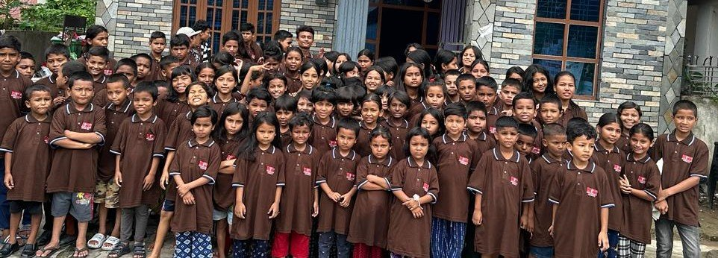
Atotal of 126 children from the Badi community, comprising 72 girls and 54 boys, currently reside in a hostel facilitated by the Child Protection Center. The hostel provides a safe and nurturing environment, ensuring their well-being and security. In addition to a secure living space, the children have access to educational facilities, enabling them to pursue their studies and build brighter futures. This initiative represents a crucial step toward fostering social inclusion and addressing the educational needs of marginalized children in the community.

!$= cg';"lrx?
!$=! afn ;+/If0f s]Gb|sf afnaflnsfx?sf] laj/0f
!$=@ ;+:yfsf] cfDbfgL tyf vr{ laj/0f

;+:yfsf] ;Dks{ 7]ufgf
afbL ;/f]sf/ d~rg]kfn
BadiSarokarManch Nepal
Rff}yf] aflif{s pT;j @)*@

;+:yfsf] gfd M afbL ;/f]sf/ d+r g]kfn
s]Gb|Lo sfof{nosf] :yfoL 7]ufgf M aL/]Gb|gu/ gu/kflnsf *, Sofk; If]q s0ff{nL k|b]z
kmf]g g+=M )*# %()(%)
Website: bsmn.org
Email: bsmn2078@bsmn.org

afbL ;/f]sf/ d+r g]kfn,
Face Book:
Badi Sarokar Manch Nepal

Twitter:
Instragram:

;Dks{ AolQm M != lxSdt axfb'/ afbL -cWoIf_
Dff]afO{n g+= (*$$*(%$^^, (*!%%()#!(
Email: hikmatbd123@gmail.com
Whatsapp: 9844895446

@= ;'snfn afbL -d'Vo sfo{sf/L clws[t_
Email: nepalisuklal@gmail.com

#= k|sfz afbL -n]vf tyf k|zf;g clws[t_

;Dks{ sfof{no M yfkfynL, sf7df08f}+
;Dks{ AolQm M lxSdt axfb'/ afbL -cWoIf_
Dff]afO{n g+= Dff]afO{n g+= (*$$*(%$^^, (*!%%()#!(
Email: hikmatbd123@gmail.com

wGoafb

